Please note this is a template version of our online form, so applicants can draft their answers before submitting their application online.

Please submit your final application via the online form
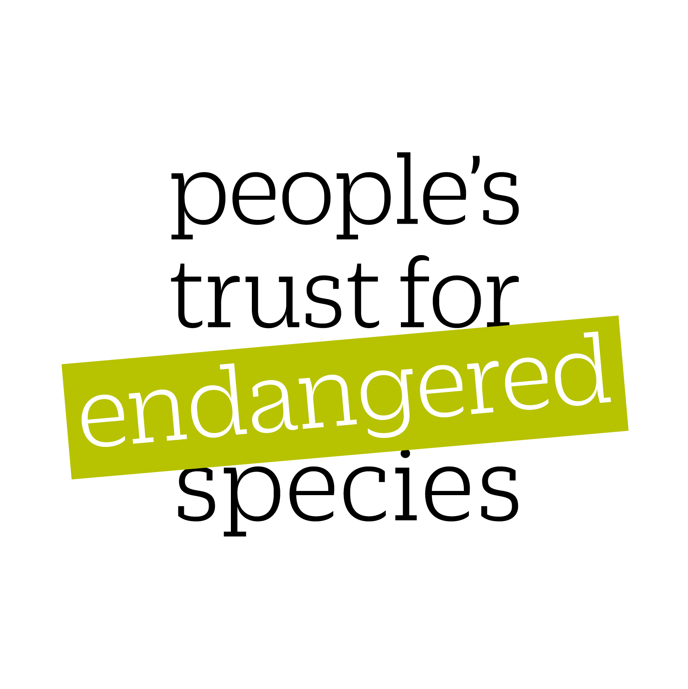
PTES grant type:

Project title:

Primary species (common name):

Primary species (scientific name):

IUCN classification:

Other species included in the project (common & scientific names):

Primary country the project is being undertaken in:

Project leader title & name:

Project leader institute or NGO:

Post held by project leader:

Project leader email:

Project leader address:

Project leader nationality:

Total amount being requested from PTES: (please give amount in pounds sterling)

Start date of project:

End date of project:

Project summary (up to 100 words) (please describe your project in simple, non-technical language e.g. The team, working in conjunction with local fishermen, will aim to get fishing legislation revised. Through sampling both turtles caught and the stock available, the researchers will seek to provide a definitive list of regulations to guide future fishing practices such as minimum and maximum shell length and defined closed seasons. On an ongoing basis, the team will work to monitor the level of compliance with these new regulations.)

PAGE 2 – Project detail

+ Main aims (please list the main aims of your project in no more than 300 words)

+ Threats being addressed (please describe what threats your project is addressing in no more than 500 words)

+ Project methodology (please describe your methodology in no more than 500 words)

+ Project timescale (please include a timescale of activities highlighting milestones within the project where progress can be assessed in no more than 300 words)

+ Study site (please describe the study site where the fieldwork will take place in no more than 200 words)

+ Conservation Evidence Please include information here about previous projects that have conservation evidence relating to the species you are working on or the methods you are using. Visit https://www.conservationevidence.com/ and search for information relating to your work. If there is no evidence on previous work relating to your species, please search for a method instead. For example you could search for eDNA methods, rather than otters; or boma strengthening rather than snow leopards.

Did you search the Conservation Evidence website?*
- Yes
- No
Did you find useful information on the Conservation Evidence website?
- Yes
- No
Have you modified your methodology based on the information you found on the Conservation Evidence website?
- Yes
- No
Would you like your findings to be published on the conservation evidence website?
- Yes
- No

+ Outline how this project relates to other conservation work on this species, and how it addresses both worldwide and local conservation plans for this species. How will this project address the IUCN priorities for the species, both in general and in the specific area you are working in? (no more than 500 words)

+ What are the likely outcomes of your project and how will they contribute to the long-term conservation of this species? (no more than 500 words)

+ How will you disseminate your results? (no more than 200 words)

+ Project budget

Category | Item | Cost per item | No. of items | Total cost | Amount requested from PTES
Staff costs | PI salary per month | £500 | 3 months | £1,500 | £500
Staff costs | Field assistant (at £30 per month) | £30 | 12 months | £360 | £360
Lab equipment | PCR analysis | £5,000 |  |  | £5,000
Lab equipment | 1000 swabs | £1,000 |  |  | £0
Travel | Petrol per month | £50 | 6 months | £300 | £200

+ How much is your organisation contributing to the total budget?

+ What other external funds have you secured towards the budget?

+ What other external funds are you waiting to hear about?

+ Your organisation’s finances (please fill in the details

 | Accounts to December two years ago | Accounts to December one year ago | Current Budget
Income
Expenditure

+ Describe the size and staff structure of your organisation, your governing body and your financial situation.

E.g. PTES is a registered charity consisting of 15 staff members, governed by a board of trustees, and supported by thousands of volunteers. Typically over 80% of our annual income is derived from public donations and legacies. We also receive a smaller amount of income from grants for specific projects.

+ Are you resident in the country/ area you are proposing to work in?

+ Details of other personnel involved in the project (include supervisors/ staff for whom you are requesting salaries or living and travel costs etc.) (include names, emails and institutes & posts held.):

+ Previous applications (please briefly list any previous applications to PTES and whether or not they were successful. If so, how much were you granted and when.)

+ Have you applied to PTES previously?

+ Was your application successful?

+ If yes have you submitted your final report?

+ Is this a resubmission of a previously unsuccessful application?

Risk assessment – please detail any risks to your project (up to 200 words)

Other – please include any other information you feel may support your application (up to 200 words)

Referees – please supply the names and addresses of two referees – one of whom knows you personally and can comment on your ability to carry out the project, the other referee must be an expert in the species you are hoping to work on (preferably sitting on the IUCN Species Specialist Committee). Both referees must be external and not work within your organisation. Please ask each referee to email a letter of support by the application deadline to grants@ptes.org. The project title should be included in the subject heading. Emails should be submitted from an institution email account. References sent via web-based services such as Yahoo, Gmail or Hotmail cannot be accepted. References must be received by the grant deadline.

Appendices please include information on the following:

1 – Species population and distribution (IUCN red list)
2 – Species threats (IUCN red list)
3 – Species conservation and research actions (IUCN red list)
4 – List up to three titles of recent published papers on primary species
5 – Conservation Evidence sources table and conservation actions table

