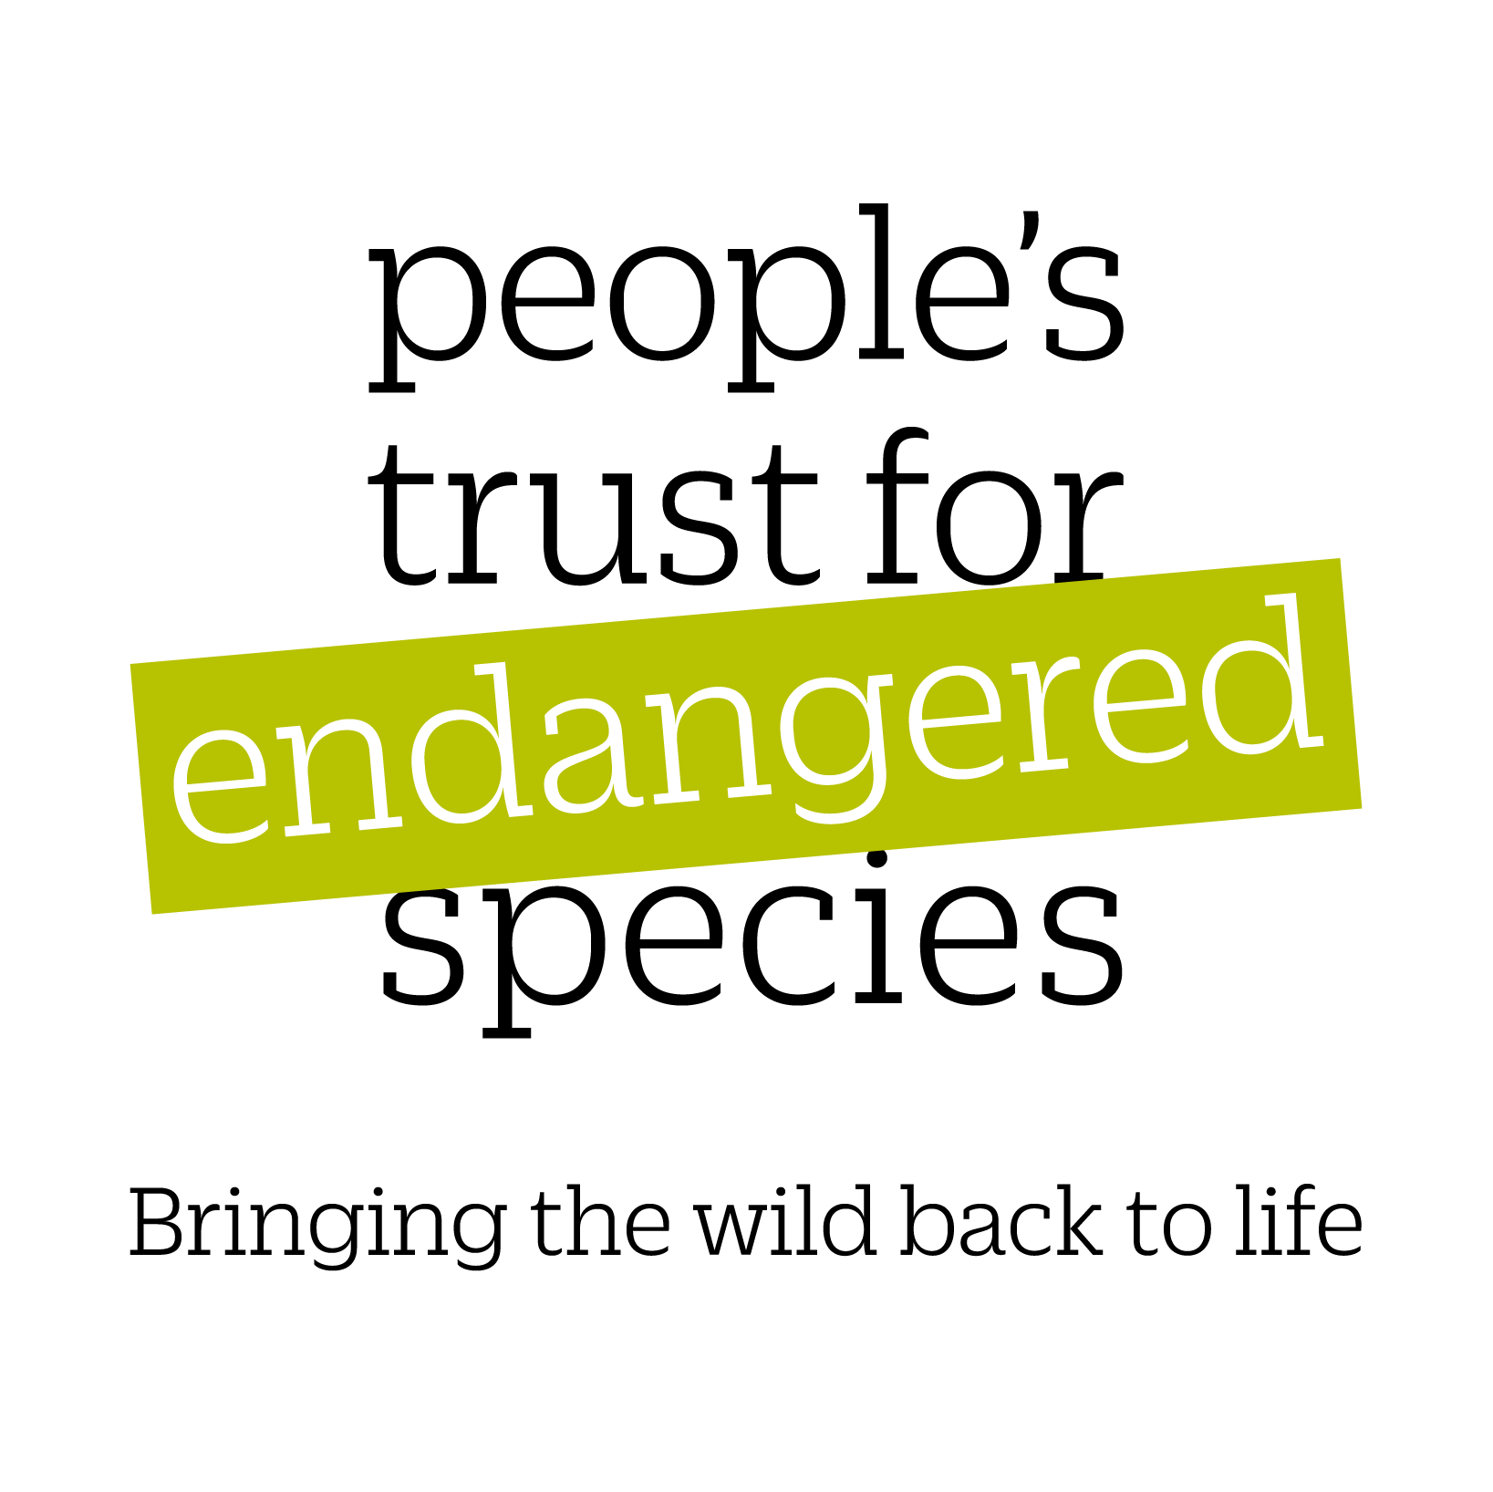

PTES INTERNSHIP APPLICATION FORM

PART 1: GENERAL INFORMATION

Applicant | Research Institution or conservation NGO  at which intern will be based
Name: | Name:
Home address: | Address:
Telephone: | Supervisor name & position:
Email address: | Supervisor email address:
Undergraduate course currently being (recently) completed:

University:

Department and Address:

Anticipated/ actual class of degree:

Date of completion of degree:

PART 2: PROPOSED RESEARCH PROJECT AND TIMETABLE

Title of project:

Species involved and conservation status:

Summary of your proposed objectives (not more than 500 words):

Timetable:

Project start date:

Project end date:

Anticipated date of completion of final report:

PART 3: BUDGET

Category | Item | Cost per item * | No. of items | Total cost | Amount requested from PTES
e.g. Living costs | Monthly rent | £300 | 3 months | £900 | £900
e.g. Travel | Monthly petrol for travel to field site | £30 | 12 months | £360 | £360
e.g. Field equipment | Longworth traps | £15 | 50 | £750 | £500
e.g. Lab equipment | 1000 swabs | £1,000 |  |  | £0
TOTAL REQUESTED

* All estimated costs must include the cost of VAT where applicable

PART 4: OBJECTIVES OF INTERNSHIP
How will this internship help you to foster your career?

Give details of the methodology you will use to achieve your objectives:

Anticipated conservation outcomes:

How will you evaluate the project as it progresses?

Any other information in support of your work that you would like the Advisory Body to take into account when considering your application:

I certify that the above information is correct to the best of my knowledge and belief.

Applicant Signed on behalf of the Institution

Signed......................................... -----------------------------------

Date................................................. --------------------------------------
The above institution accepts
I have attached responsibility for Health and Safety
and any other legal issues.
My CV ----

Reference ----

Please remember to submit a CV with your application form, along with two letters of support. One should be from your course tutor outlining why you would make a good candidate for a PTES internship grant, the other should be from your host organisation explaining how it will support you throughout the project and what learning outcomes you will be expected to achieve.

Please email an electronic copy of the completed form to grants@ptes.org

The information that you provide will be held by People’s Trust for Endangered Species. For information on how PTES processes personal data, please see our privacy policy. You can change how you hear from us via enquiries@ptes.org or by calling 020 7498 4533.

The information collected through this grant application, is shared with a number of experts for assessment and to help guide conservation action.

