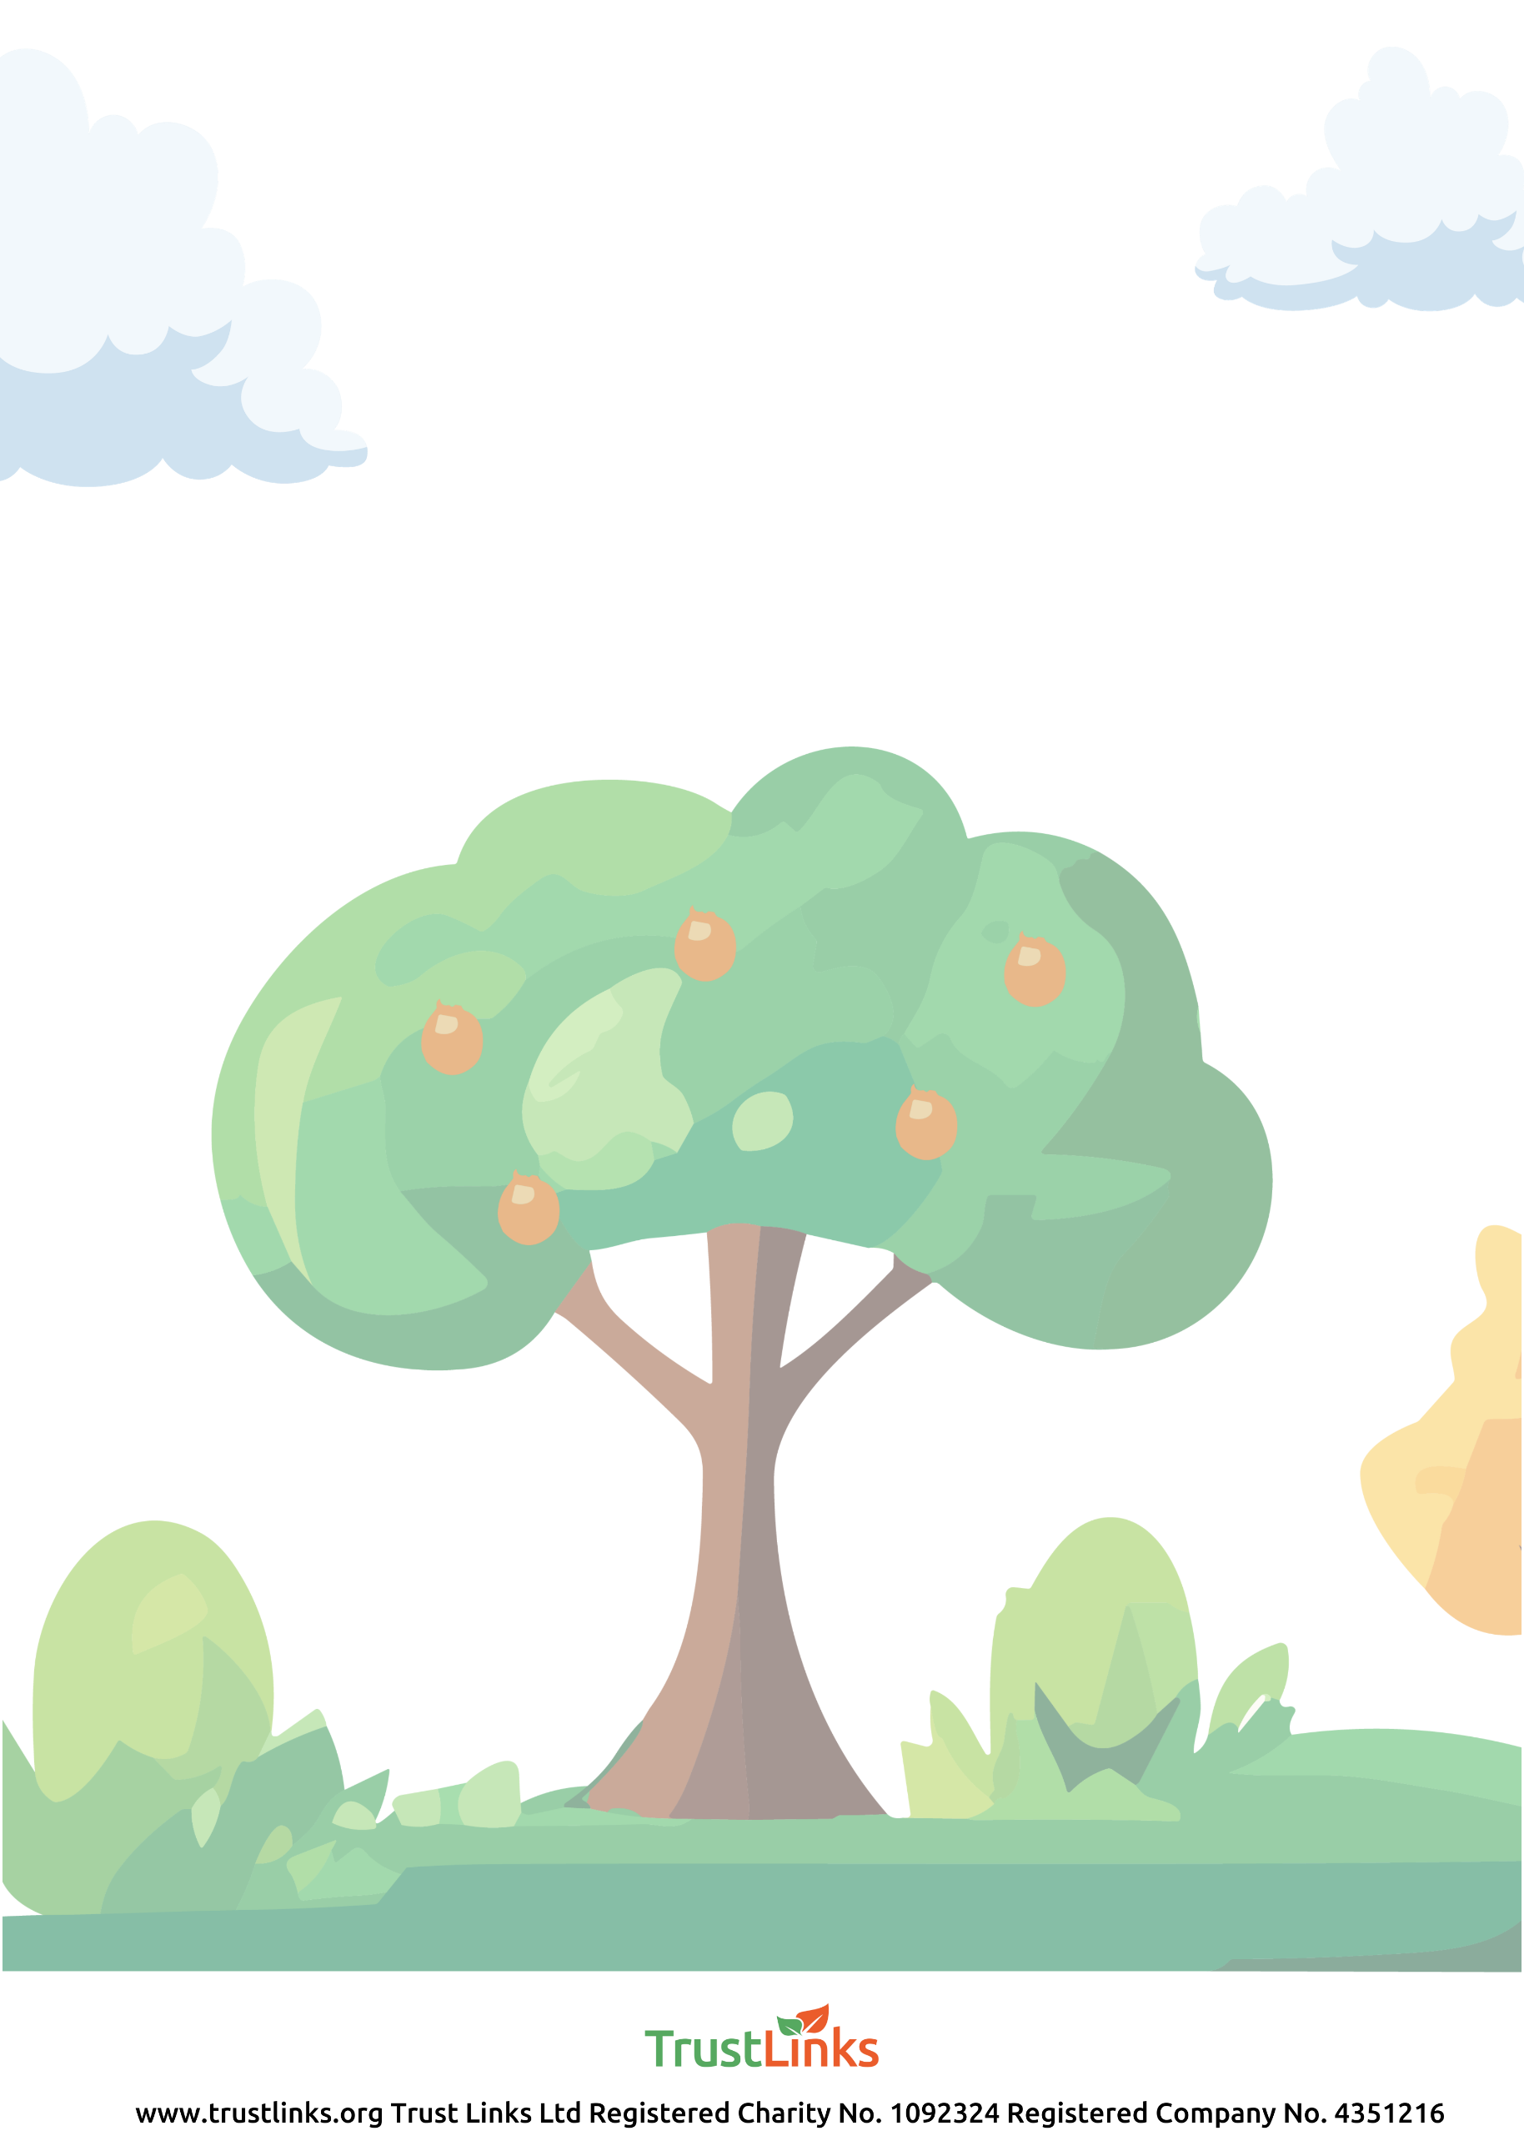

October 2023 to October 2024 | What’s on
October - Apple Day Sat 7th Oct | Launch Stall
November – Wednesday 1st November Half Term | Building a bug hotel
December - Monday 4th January | Making a willow Christmas Wreath
January - Sunday 14th Jan | Coppicing and dead hedging with conservation volunteers
January - Sunday 21st TBC | Wassailing
January - Sunday 28th January | Fruit Tree pruning
March - Saturday 23rd March | Foraging
Also to come – Art in the orchard, Forest School, Wildflower + insect survey, Nature Photography, Jam making, Scything.

For the November workshop - register with Eventbrite
https ://www.eventbrite.co.uk/e/727483662217?aff=oddtdtcreator
For more info and updates - email ecodays@trustlinks.org

