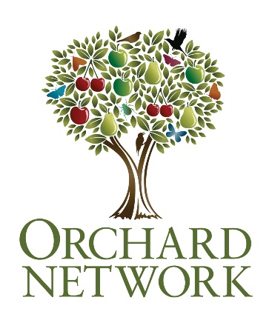

The 28th April 2023 is

Orchard Blossom Day

This information can help you take part.

Register your venue and invite people to come along for a special day out.

Blossom has mostly disappeared from our lives. This new celebration will bring it back.

Blossom is good for wildlife, good for the soul, and absolutely essential for fruit production, so when your orchards or fruit trees are at their best, open your orchard up to the local community, hold a special event, take a walk amongst blossom trees, and join the celebration on social media channels, or just quietly enjoy the best that nature has to offer. Orchard Blossom Day will be celebrated every year – so if you can’t do anything this year, plan ahead for the next one. Use these four resources to help plan your event.

- The first thing is to think about what you can do. Have a look in the Guide to organising Orchard Blossom Day events and activities for ideas.

- The next action is to register the event with the Orchard Network
www.orchardnetwork.org.uk/orchard-blossom-day

Follow the link to register a venue.

IMPORTANT: This will only provide a pin on a map – you will need your own website, Facebook page, or poster to link to, ideally with information about your event. Add information to your internet presence, or make a poster using this template (or indeed make one of your own, though please include the Heritage Lottery Funded image – link below). Place this on a shared drive and create a download link for us to use

- Create some content on your web presence or make and share a poster:

Here’s some suggested text:

Short text:
Orchards across the nation will open their gates to visitors for Orchard Blossom Day at the end of April, offering tours and activities, orchard produce and a chance to enjoy the beauty of fruit tree blossom. Find your local open orchard or discover more about heritage orchards at www.orchardnetwork.org.uk.

Medium text:
Orchards across the nation are preparing to open their gates for Orchard Blossom Day. This new annual celebration of fruit trees, flowers and food launches across the UK and Europe on and around the last Friday of April. The Day is celebrating orchards as magical places for the benefit of people and nature, places of a huge but dwindling variety of fruit trees and places in need of conservation across Britain and Europe. Find your local open orchard or discover more about heritage orchards at www.orchardnetwork.org.uk.

Long text:
On 28th April orchards across the nation are preparing to open their gates for Orchard Blossom Day. Numerous actions will take place all over Europe - from Britain to Tyrol and from Transylvania to the Atlantic. Be part of it and enjoy the day - at home, at an event, or just out and about. Events will include picnics, tours and activities, orchard produce to taste and buy, and the simple pleasure of walks amongst the blossom. This new annual celebration of fruit trees, flowers and food launches across the UK and Europe on and around the last Friday of April. The Day is partly for the joy of celebrating orchards as magical places for the benefit of people and nature, places of a huge but dwindling variety of fruit trees and places in need of conservation across Britain and Europe. But it is also to raise awareness of local food production using more wildlife friendly methods.

Supported by the dozens of organisations that comprise the UK Orchard Network, this new Day will complement the hugely popular Apple Day events started by Common Ground in 1990 to celebrate the apple harvest in all its variety.

Find your local open orchard or discover more about heritage orchards at www.orchardnetwork.org.uk.

Logos can be downloaded from here:

Orchard Network

European Orchard Day

Lottery Funded

Images free use for Orchard Blossom Day publicity only (otherwise various copyrights apply) can be downloaded from here:
Images

Some samples of images you can get from the shared drive above:

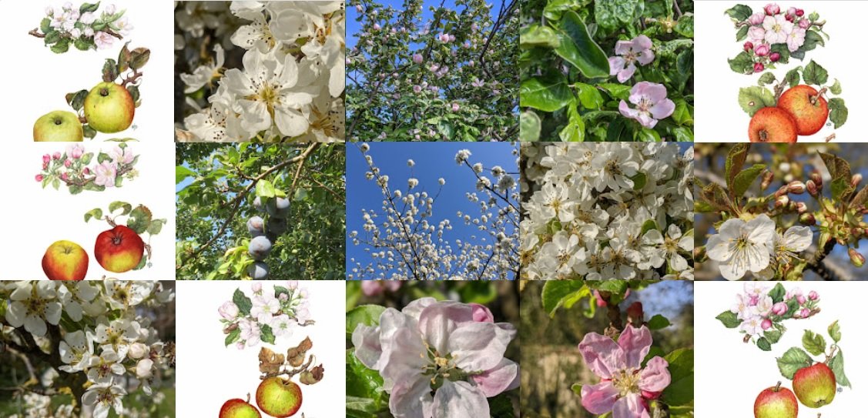

- Signpost your social media to the following:

- #OrchardsEverywhere
- #BlossomWatch
- @UK_Orch_Network
UK_Orchard_Network

