#OrchardBlossomDay

#OrchardsEverywhere

#streuobstueberall

European Orchard Day 2022
On 29 April, countless balloons rise up (metaphorically) from the flowering traditional and meadow orchards all over Europe. Europe is celebrating Orchard Day and invites you all! The hashtags of the participation and experience are #OrchardBlossomDay #OrchardsEverywhere and #streuobstueberall. There is a dedicated European website www.orchardseverywhere.com
The Orchard Day takes place every year at the end of April as a day of participation and experience. Orchardists from all over Europe organise "orcharding" activities for visitors around the intangible cultural heritage and invite you to participate.
A colourful programme inviting Europe
On 29 April, numerous actions take place all over Europe - from Britain to Tyrol and from Transylvania to the Atlantic. Be part of it and enjoy the day - at home, on an excursion or on holiday. A press conference on 29 April at 10 am, which you can follow in the livestream on the website, will launch the Orchard Day. A map of events can be found at www.orchardseverywhere.com/en/aktionen. You are invited not only to be a welcome orchard visitor but also to personally join our Orchard supporters group. Appreciate orchards by sharing your knowledge, stories and photos with those around you and view the wide range of products available for sampling and purchase.
A loud motto that inspires Europe
Under the Instagram and other hashtags #orchardseverywhere or #streuobstueberall we aim to inspire the whole of Europe! Because in Germany, Austria, the British Isles, Slovenia, Luxembourg, Switzerland and many other countries there are people with a great passion for orchards. Collectively, we want to show and pass on this passion.
A blossoming day that unites Europe
Traditional orchards, also called meadow orchard in some countries, are characterised by their large, widely spread and scattered fruit trees of many species and varieties. These orchards are home to many rare and endangered animal and plant species. The orchards and their meadows are a man-made cultural landscape only existing and surviving through cultivation. Our traditional knowledge of fruit tree care, processing and much more is the fertile soil of this cultivation. In many parts of Europe, traditional and meadow orchard shape entire natural and cultural landscapes, but the number of fruit trees is dwindling. The European Orchard Day shines a spotlight on the beauty of the flowering orchards and the delicious fruit products.
You want to become a host?
Be part of the European orchard community and organise an event in the midst of the blossoms! Anything is possible and welcome, for example a blossom breakfast, a product tasting, a social media campaign, a photo competition or a cosy coffee chat. Every single activity inspires enthusiasm for the blossoming orchards, their careful cultivation and wonderful trees. You can add your activity here: http://orchardseverywhere.com/en/aufruf-und-eintragung-von-aktionen/
On the initiative of the ARGE Streuobst and the Umweltdachverband from Austria, the last Friday in April was declared the "European Orchard Day ". Since then, Hochstamm Deutschland e.V. has been responsible for promoting and coordinating the Orchard Day. The ARGE Streuobst from Austria and the UK Orchard Network from the United Kingdom provide active support.

515 words, 8473 characters incl. spaces
Background information:
Verein Hochstamm Deutschland e.V.
Hochstamm Deutschland e.V. is a non-profit, nationwide association based in Baden-Württemberg that campaigns for the preservation of meadow orchards. Hochstamm Deutschland is backed by orchard initiatives, local authorities, associations and private individuals.
The aim of the association is to support friends of orchards in preserving the remaining stock and to provide ideas for its further development - through networking, exchange and participation. Hochstamm Deutschland offers a platform for this, among other things, on the association's own homepage (www.hochstamm-deutschland.de). The association also works to ensure that the time- and labour-intensive care of a meadow orchard is not just a matter of the heart - with marketing channels and ideas that create an economic basis for cultivation on tall orchards. This includes the current community marketing project. There, the association is working with numerous farmers and other experts to develop a joint seal for "100 % orchard products".
In addition, the association, together with more than 1.3 million supporters, managed to get orchard cultivation listed in the Federal Register of Intangible Cultural Heritage in Germany. This has brought orchard cultivation increasingly into the public spotlight. This attention contributes to the preservation of the orchard culture and the knowledge associated with it. In the wake of this success, the “European Orchard Day" was established by various initiators. It takes place annually on the last Friday in April.

Intangible Cultural Heritage
Intangible cultural heritages are cultural expressions that are directly supported by human knowledge and are passed on and developed from generation to generation. Intangible cultural heritage is not tangible, but is bound to people and kept alive by the commitment of its bearers.
Orchard landscapes in the form of fields, meadows or avenues with tall, large-crowned fruit trees have emerged from agricultural and cultural development and are thus directly linked to human knowledge. The planting, cultivation and care of orchards, the cultivation of fruit varieties and the harvesting and processing of fruit are based on extensive empirical knowledge in dealing with nature. In addition to cultural expressions such as harvest festivals and rituals, special handicraft techniques, e.g. for the care of orchard trees, have been developed and refined over centuries. The cultural characteristics of orchards are consistent with the UNESCO criteria in the following respects: Knowledge and customs related to nature and the universe, traditional craft techniques, customs, rituals and festivals.
The idea of adding scattered fruit to the list of intangible cultural heritage originated four years ago at the State-wide Scattered Fruit Day in Baden-Württemberg in 2015. Since then, the initiators have passed on and discussed this idea within the framework of the Scattered Fruit Days, e.g. via their own newsletter. Hochstamm Deutschland e.V. partly emerged from the networking of the Streuobsttage and took the initiative in 2019 to organise the application as a nationwide cooperation project. In 2021, the application, which was joined by over 1.3 million supporters, was approved and scattered fruit cultivation was included in the nationwide register of intangible cultural heritage. Hochstamm Deutschland e.V. asks for correct use of language in publications: Note on language use. Please note in particular that in connection with the intangible cultural heritage, one should always speak of "scattered fruit growing" - not of scattered fruit, scattered fruit meadows etc. Currently, only Hochstamm Deutschland e.V. is authorised to use the logo "Intangible Cultural Heritage" for non-commercial purposes.
The association is supported in its nationwide cultural heritage campaign with funding from the Federal Programme for Rural Development (BULE).
PHOTOS for free use
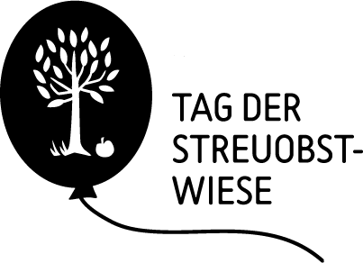 | "Logo Day of the Orchard Meadow"  The Day of the Orchard takes place annually on the last Friday in April. It is a Europe-wide day of participation and action around the intangible cultural heritage "orchard cultivation".
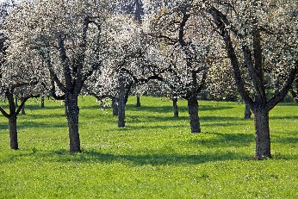 | "Diversity, Culture and Europe" Source Manfred Wolf  Large fruit trees of many varieties take root at irregular intervals in the meadows. A high number of partly endangered animal and plant species are at home there.  Source: Manfred Wolf
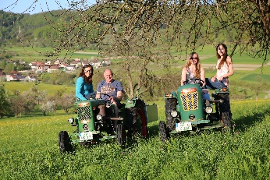 | "Experience orchard" Source Korbinian Fleischer  On 29 April, numerous actions and events will take place all over Europe. The programme is as diverse as the cultural landscape itself.  Source: Korbinian Fleischer

Contact Hochstamm Deutschland e.V.
Office c/o neuland+ GmbH & Co KG
Hornungshof 3-4, 74575 Schrozberg
Hannes Bürckmann & Sophia Philipp
Tel.: 07936 / 99 05 20
Mobile: 0172 / 712 65 97
kontakt@hochstamm-deutschland.de
www.hochstamm-deutschland.de

Association headquarters:
Niedenbach 13, 72229 Rohrdorf
Chairperson: Martina Hörmann
Register of Associations: VR 723 737
Register court: Stuttgart

