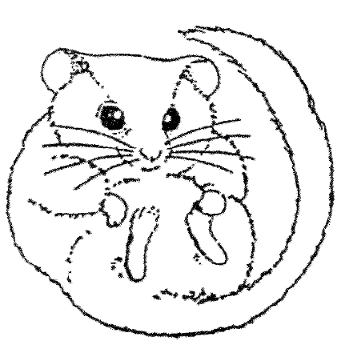

Dormouse Training Log

Name: ………………………………………………

Dormice are protected under the Wildlife and Countryside Act (1981 as amended) and the Conservation of Habitats and Species Regulations 2010. Dormouse survey work involving the disturbance and handling of dormice in nest boxes or nest tubes requires a licence from Natural England or Natural Resources Wales. To receive a licence you will need references from two people who have held a licence for dormice within the last two years for the methods you wish to have on your licence.

This checklist is designed to ensure that the highest standards are maintained and should be used to support your licence application.

All evidence recorded must be conducted to a satisfactory level of competence in the presence of a licence holder where specified.

Each section of this training log should be signed by either one or two dormouse licence holders, as specified in the first column. These people can then act as your referees when you apply for a licence. The activities listed are classed as either advisory or mandatory.

The timescales for training will vary greatly depending on the opportunities you have to practice with dormice on surveys and the availability of licence holders to work with you. You should expect to have completed a minimum of at least one survey season and probably two, before completing your licence application although this period may be considerably longer.

It is highly advisable that people wishing to train for a licence attend a Dormouse Ecology and Conservation course. Course details are listed on the PTES website:

www.ptes.org/dormousetraining

Completion of this record in no way obligates any referee to provide you with a reference for Natural England or Natural Resources Wales; references remain entirely at the referee’s discretion.
The granting of Protected Species licences is at the discretion of Natural England and Natural Resources Wales and applications may be rejected, or licences revoked at any time.

See the Natural England and Natural Resources Wales websites for further details and licence application forms:

http://naturalresourceswales.gov.uk/apply-buy-report/apply-buy-grid/protected-species-licensing/?lang=en#.U9dtreNdXTo

http://www.naturalengland.org.uk/ourwork/regulation/wildlife/licences/applicationforms.aspx

Evidence of experience gained:

Your trainer/s should sign this section one they consider that you have gained sufficient experience in the activities listed.
 | Activity | Signature | Date
One signature | Dormouse ecology and conservation theory:  Attend theory training session¹
One signature | Dormouse Survey techniques  Attend theory training session¹
Two signatures | Dormouse Survey techniques  Practical experience  (Site and/or replace nest boxes. Site nest tubes)

 | Activity | Signature | Date
One signature | Dormouse Habitat Management  (if applicable)²  Attend theory training session
One signature | Hazelnuts:  Identify nuts opened by dormice, wood mice and bank voles and others
One signature | Nests:  Recognise typical dormouse nest, wood mouse nest, and bird nest
Two signatures | Handling:  Demonstrate how to approach a nest box and check for occupancy

1 Note that if it is not possible to attend theory training courses it may be possible for you to provide other evidence on your licence application to demonstrate that you have sufficient knowledge

2 It is important that Land managers, Rangers and Consultants have a good understanding of habitat requirements and habitat management for dormice as they may be undertaking practical work or advising others. This element of training may not be necessary if you aim to monitor an NDMP site and is not a requirement for a dormouse handling license

 | Activity | Signature | Date
Two signatures | Handling:  Demonstrate how to get dormice carefully out of a nest box, including when there is more than one animal present.
Two signatures | Handling:  Identify dormouse age classes and demonstrate appropriate handling techniques for all ages and conditions including active juveniles and torpid individuals
Two signatures | Handling:  Demonstrate how to accurately weigh individual dormice

 | Activity | Signature | Date
Two signatures | Handling:  Demonstrate how to return a dormouse to a nest box, including when there are more than one dormouse present
Two signatures | Sex determination:  Demonstrate knowledge and handling experience needed to accurately identify sex of dormice and breeding condition
One signature | Record keeping:  Demonstrate how to fill in all the recording forms in use by the National Dormouse Monitoring Programme

Surveys attended:

This is an assessment of how much experience you have acquired in dormouse surveying and dormouse handling at different sites.
Date | Site | Activity (including number of dormice handled and life stages) | Signature of licence holder

Date | Site | Activity (including number of dormice handled and life stages) | Signature of licence holder

Training courses attended:

This is a log of dormouse training courses or conferences attended

Date | Training course or conference | Signature of trainer/organiser
Notes:

