Winter pruning fruit trees
Winter pruning apples and pears helps maintain the shape and balance trees on established frameworks. It removes weak, crowded and unhelpful growth and increases the vigour of your tree in the next growing season.
When is the best time to winter prune?
For apple and pear trees this is best done between November and March, while the tree is dormant and preferably during dry, frost-free weather. Winter pruning encourages strong spring growth, and the lack of leaves means you can better see the structure and shape of your tree. If you prune a tree hard, you will almost certainly need to summer prune to thin out some of these new shoots and direct the energy into well-placed new branches. This also allows time to assess how the tree is responding before continuing the work. Healthy cropping should resume in the second year when the rejuvinated wood starts producing new fruit spurs on the two year old wood.
N.B. Stone fruits (plums, damsons, gages and cherries) should only be pruned in summer between May and September, to minimise the risk of silver leaf infection. These types of tree don’t respond well to major pruning.
How do I winter prune?
- Make a plan
Walk around your tree, mapping it in your head and decide how you will prune the tree and which branches will be retained for new growth. Take your time over this; it is all too easy to over-prune or take out a branch you later decide was worth keeping if you don’t have a plan. As well as considering which branches you will remove this year, try to think about the ones you will remove the following year, making sure you are not making your tree too unbalanced in the mean time. If the tree is looking out of balance, prop it up with a sturdy branch or post.

- Remove some dead or broken branches
These can be an access point for disease, reduce air movement around the rest of the tree, reduce light penetration, and can cause further damage to the tree if they fall.If you are keen to maintain a biodiversity friendly tree habitat some dead wood should be left because so many species rely on it. A compromise can be maintained between the needs of the tree and those organisms living on it. Large trees that are reasonably healthy are better able to support some damaged or decaying wood. Where the orchard is being managed expressly for conservation rather than for fruit production, coronet cuts can be made and snags left to create wildlife habitat. Older trees have the deadwood habitat within the framework boughs and trunk so additional canopy deadwood is less important
Large branches that appear unsafe, over-long or likely to split or are making the tree unbalanced should be reduced in length and weight. Where you have to cut off dead branches, cut to a short stub of dead wood rather than cutting into the living wood.

- Remove signs of diseased wood
Any branches that show excessive levels of disease such as canker should be disposed of by fire or removal from the site as these can act as disease reservoirs that can infect other healthy trees in your orchard.

- Remove crossing branches
These can rub against each other and cause damage, especially in high winds or when the tree is heavy with fruit. Ideally branches should be evenly spaced around the tree for best light and air penetration. Decide which is the better shaped or positioned branch and remove the other. You can either remove the other branch entirely, or cut it back to a bud that will direct the growth in a direction that occupies the canopy space better.

- Remove any badly placed or spaced branches
You want to make sure enough light and air can get to all parts of the tree. If you have several branches growing too close together, consider removing these to improve the spacing. This will encourage the strong growth of the remaining branches, makes fruit picking easier and stops branches rubbing together.

- Make fewer, larger cuts
When you are trying to re-balance, reduce the height or restore the shape of your tree, make fewer but larger cuts rather than lots of smaller ones.

- Remove old water shoot branches
Completely remove excessive young growth from the centre of the tree, unless there are any that are well positioned to become new framework branches. Select outward-growing branches to retain as this allows light and air through the centre of the tree (remember – you should be able to throw your hat through the middle of the tree!).

- Thin branches where your tree is still overcrowded
Scab, canker and mildew are all associated with overcrowded growth. Light and air penetration can reduce the instance of disease.

- In total try not to remove any more than ¼ of the canopy per year
Even though it might seem more time efficient to get the whole tree pruned quickly it is a false economy. If you prune a tree too heavily it can send out excessive growth of water shoots the next spring which you will need to prune again anyway. Pruning over a number of years also gives you time to assess how the tree is responding.

- Remove or shorten inward facing branches
Inward facing branches should be removed, or shortened to an outward facing bud so that it grows away from the centre of the tree. Ideally the centre of the tree should be kept clear of too much growth.

- Dehorning
Dehorning is essentially the act of cutting the main stem to a more convenient height. If a tree has grown beyond the desired height it is likely to make harvesting difficult and further growth will also be high up and out of reach, to the detriment of lower branches. Overly close planting or crowding out by scrub is a common cause. An old, top-heavy tree might also be prone to uprooting by wind-throw. Only dehorn a mature tree if there’s no other choice as it is a drastic measure and does little for the aesthetics of the tree.
Younger apples can have a significant section of the central leader removed without causing too much disfigurement as the laterals will even out the growth over time restoring a natural effect. Fully grown trees, particularly pears with a single straight stem, are likely to look like they’ve been brutally ‘topped’, and the wound will not heal over as effectively, which can shorten the life of the tree.
To dehorn, cut the offending branch or central leader back to a side-wards growing branch. If a lot of material needs removing, spread the work out over several years.

- Spur pruning
Spur pruning can refer to three different techniques.
- As a general maintenance procedure, it relates to the reduction of clutter on old fruiting spurs. Each year a fruit spur will produce a clutch of new buds which flower the following year. This eventually becomes an unweildy, knarled knot of wood and production decreases, so reducing the spur refreshes it. This is unnecessary if renewal pruning is practiced – where the older, tired laterals are removed and a new branch is selected to replace it.
- Spur pruning can also relate to the creation of new spurs. This is done by cutting unwanted or poorly placed new lateral growth back to three or four buds in the first winter, and in the following winter cutting out that year’s new growth again leaving only a few growth buds. The now two year old wood should have developed into fruit buds. These will fruit in year three and everything beyond these can then be removed leaving only the fruiting spurs.
- Spur removal directs the tree’s energy into new growth. Some varieties are known to ‘spur freely’, which means a lot of buds will develop into spurs. In a young tree this can cause stunted growth as the balance of energy is put into flowering and fruiting rather than extension growth. To remedy this some or all of the spurs, depending on severity of stunting, are completely removed in winter. During the following year the tree will have no choice but to put its energy into new growth. New spurs will develop, and fruit the following year.
What to do with the prunings
Major pruning work can leave behind a lot of cut material which makes a good wildlife habitat. Unless the need to clear them away is overwhelming large branches and trunks should be left dotted around or stacked out of the way to rot down. Smaller branches can be stacked in loose brash piles for wildlife. Thousands of small insects will make it their home and provide a food-source which the small songbirds like blackcaps and robins will soon discover.

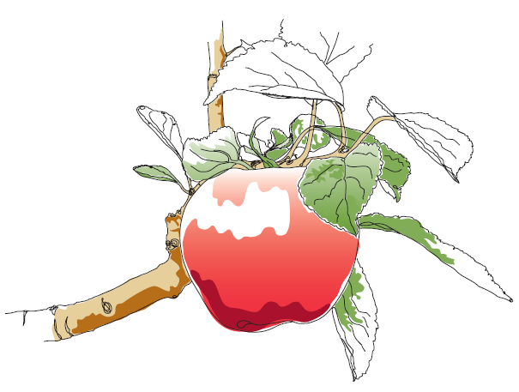
This information and other practical guides are available on the orchard pages of our website at www.ptes.org/orchards

