Why do we need to prune fruit trees?
The successful cultivation of fruit trees requires pruning. But why is it that we can’t leave trees to grow as nature intended? Pruning trees allows you to direct the energy of your tree where you want it, whether that is growth or fruit. If grown without intervention, fruit trees will grow in such a way as to reproduce themselves in as large quantities as possible, but this doesn’t always result in the best shaped tree or the best quality fruit.
Preserving and restoring old trees
Old trees are fantastic for wildlife, and have significant cultural value so should be maintained in your orchard where possible. Old or neglected trees can be rejuvenated through restorative pruning which can increase their vigour and prolong their life.
Shaping young trees
Young trees need to be shaped through formative pruning to develop the strong framework that they need to bear the weight of fruit crops. Formative pruning also allows you to shape your trees to particular style shapes such as goblet or central leader style. The shape traditionally depends on factors such as region and fruit type, e.g. dessert apple trees are more often goblet shaped, and cider apples on trees with a central leader.
Removing damaged and badly positioned branches
Badly positioned, touching or crossing branches can be damaged in the wind as they rub against each other. When the bark rubs off it creates an entry point for infection and will weaken the tree mechanically. Major limb failure can also damage healthy branches.
Removing damaged and badly placed branches focuses the energy of your tree into producing stronger and better placed branches.
Increasing the light and air penetration
Airflow through the tree helps to remove moisture reducing the chance of fungal infections and other air-borne diseases. Sunlight penetration to all branches of a tree encourages large healthy leaves and buds, increasing the fruit quality and allowing it to ripen fully and colour in the sun.
Pruning overcrowded and badly placed wood means you can develop evenly spaced branches that allow maximum air and light penetration.
Pest and disease control
Wood heavily infected with scab, mildew, canker or silver leaf can be removed to reduce the likelihood of infecting other trees. The likelihood is that the spores will still be in the area as it is very difficult to prune out all canker from an orchard, but reducing the quantity will help. The best pest and disease prevention is cultivating healthy trees that can fight and recover from infection.
Reducing the need for sprays in this way is beneficial to orchard wildlife which will in turn contribute to pest management. For more information on this visit our pest and disease pages.
It is important to differentiate between dead wood and diseased wood. Dead and decaying wood isn’t necessarily a sign of poor health but does form fantastic wildlife habitat. Dead wood can be retained unless it poses a threat of further damage to the tree.
Balancing vegetative growth and fruit production
Fruit grows best on wood that is 2-5 years old, but old unpruned trees tend to produce large crops at the expense of new growth. This means that over time fruit quality can become poor, as it is all being produced on very old fruiting wood. Pruning helps maintain the balance as it causes dormant buds in the old wood to produce vegetative growth that will become the next young fruiting wood. Pruning controls the age and position of the cropping wood which will improve fruit quality.
Managing tree size and shape
Unpruned trees can develop overcrowded crowns of twigs in close proximity. These thick crowns put them at risk of wind throw in autumn and winter storms. This can result in limb loss, tree fall or root damage, all of which directly affect the health of your tree.
Pruning to restrict the crown, the height or the spread of your tree can reduce the chances of this damage, as well as balancing shape of the tree.
Grating material
The prunings can be used as scion material to propagate new trees. Prunings taken in the summer can be bud grafted to rootstock, and material pruned off when your tree is dormant can be used in bench grafting.
Pruning can also increase the vigour of stagnated trees, encouraging strong vegetative growth in trees which would otherwise not produce enough new growth to graft from.
The material cut off in pruning can in these ways help to perpetuate old, local and rare varieties.

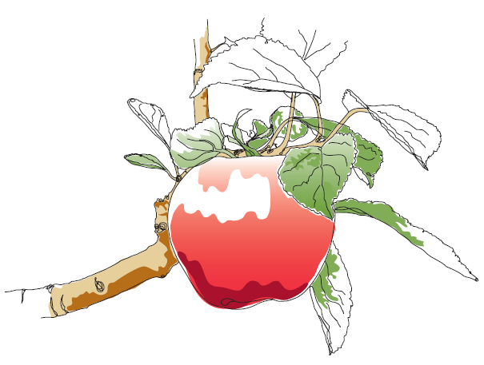
This information and other practical guides are available on the orchard pages of our website at www.ptes.org/orchards

