Restorative pruning fruit trees
What is restorative pruning and why do we do it?
Old “veteran” trees provide an invaluable resource for biodiversity as well as still producing a sizeable fruit crop. However if you have some old neglected trees, they might be overgrown, not producing quality fruit and be at a greater risk of wind damage and disease. These neglected trees can be brought back into good shape and productivity through careful restorative pruning. Even a relatively young tree that has been neglected will require some fairly serious pruning to get it back into shape.
A neglected tree that has suffered from a long-term lack of pruning may become dominated by upright growing branches, with the only live growth on the outer branches and twigs with lots of small fruit on tired and cluttered spur systems. If the tree is still growing vigorously this growth forms a dense canopy, shading the tree below. This prevents any new growth forming so the tree gradually dies off underneath, leaving it top-heavy and unbalanced with bare lower limbs. Branches may become overly long and heavy, putting the tree at risk of wind-throw and the limbs at risk of splitting. A crowded canopy is also a magnet for pests and disease.
When do I carry out restoration pruning?
For apple and pear trees, this is a winter job, done while the tree is dormant and during dry, frost-free weather. Winter pruning encourages strong spring growth, and the lack of leaves means you can better see the structure and shape of your tree. If the tree grows strongly in the first year after pruning then it is probably in good health. Healthy cropping should resume in the second year when the rejuvenated wood starts producing new fruit spurs on the two year old wood. If growth is still weak after 3-4 years then either the pruning was too light or the tree is failing.
N.B. Stone fruits (plums, damsons, gages and cherries) should only be pruned in summer between May and September, to minimise the risk of silver leaf infection. These types of tree don’t respond well to major pruning.
How do I prune an old fruit tree?
Many of the pruning techniques you will use to restore old and neglected fruit trees are the same as those you would use in normal winter pruning as practices used in these two types of pruning overlap. Please refer to ourguide on winter pruning and apply these guides when undertaking restorative pruning. In addition, the information below refers specifically to restoring older, more neglected trees.
In total try not to remove any more than ¼ of the canopy per year
Never take out more than 25% of the canopy of old trees in one year, as this can sometimes shock old trees causing death so major restoration will need to be spread across a few years, particularly on old trees. Even though it might seem more time efficient to get the whole tree pruned quickly it is a false economy. If you prune a tree too heavily it can send out excessive growth of water shoots the next spring which you will need to prune again anyway. Pruning over a number of years also gives you time to assess how the tree is responding.

Some old trees have long since stopped producing new growth
Some trees haven’t necessarily lost their shape, but seem to have stopped growing altogether, although there’s normally one or two branches at the very top that have put on a few inches of growth. These trees can be brought back into vigour through making a number of smaller cuts to stimulate new growth. If excessive water shoots grow these will need to be thinned in summer, retaining a few to make the next framework branches. This is a good way to stimulate your tree into producing new growth that you can use as scion wood to graft new trees.

Reduce the height – dehorning
Sometimes old fruit trees can become unmanageably tall. If they have been growing in an overcrowded neglected orchard they may have grown up so high that they have become top heavy and more vulnerable to toppling in winds. It can also mean you can’t easily pick the fruit. In these cases it can be good to reduce the height of the tree by removing or reducing the larger upright branches or the central leader. If reducing the height dramatically, it is best to do this in stages over a couple of years to reduce the shock to the tree. For more information about dehorning see the winter pruning guide.

Mulch the base of the tree
After pruning it is often a good idea to mulch around the bottom of the tree. Old neglected trees may well be starved of nutrients.

Pruning a leaning tree
Leaning trees can go on producing fruit for many years to come. If your tree is leaning it is worth giving it a support post, as one heavy crop or strong wind could cause the tree to topple over. As well as adding physical support to the tree, you can prune in a way that balances out the tree. Make larger cuts on the side the tree is leaning towards to reduce the weight, and small cuts on the other side to promote vegetative growth to help reduce the imbalance. Fallen trees will often still have a few roots attached which can continue to sustain a part of the tree. If this is the case, pack soil under and around the fallen trunk to promote re-rooting. Occasionally this can give the tree a complete reboot and the new roots and vigorous growth will for all intents and purposes be a new tree!

What to do with the prunings
Major pruning work can leave behind a lot of cut material which makes a good wildlife habitat. Unless the need to clear them away is overwhelming large branches and trunks should be left dotted around or stacked out of the way to rot down. Smaller branches can be stacked in loose brash piles for wildlife. Thousands of small insects will make it their home and provide a food-source which the small songbirds like blackcaps and robins will soon discover.

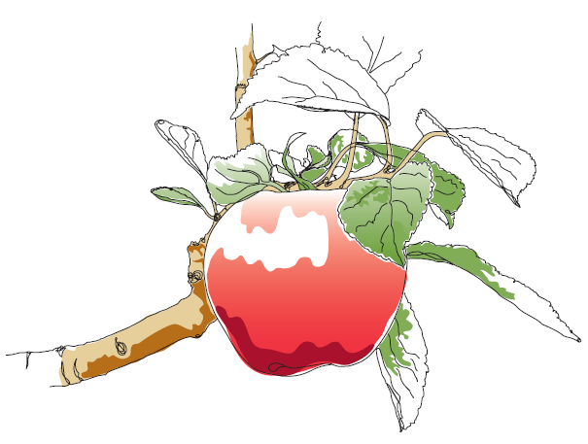
This information and other practical guides are available on the orchard pages of our website at www.ptes.org/orchards

