Template title
Template text
Template heading

Protecting orchards

Traditional orchards – a priority habitat
Traditional Orchards were added to the list of priority habitats in 2007. This came about as a result of campaigning by organisations such as Common Ground and Local Orchard Groups to highlight the importance of Traditional Orchards for wildlife and discussions and scientific research commissioned by English Nature (now Natural England). The application for priority status received strong support from a range of nature conservation organisations.
Definition
Traditional Orchards are defined, for priority habitat purposes, as groups of fruit and nut trees planted on vigorous rootstocks at low densities in permanent grassland; and managed in a low intensity way.
The minimum size of a Traditional Orchard is defined as five trees with crown edges less than 20m apart. However the potential biological and genetic interest of sites with fewer trees, such as relict orchards and individual trees within gardens, is noted. Where appropriate these should be considered as potential restoration sites. It is recognised that other sites which fall outside the definition, such as organic bush orchards and fruit collections in walled gardens may also have biodiversity value, as well as historic, cultural and genetic importance.
Implementation
At the national level, each action plan is led by a Lead Partner (usually a government agency or conservation organisation or charity). The Lead Partner takes responsibility for co-ordinating a steering group of several organisations. Together, they work towards implementing the action plan. At the local level, Local Biodiversity Action Plans (LBAPs) contribute to the UK BAP, working locally (usually county level) to address the needs of habitats and species important in their area. Seventeen of the LBAPs have specific targets for the conservation of Traditional Orchards.
The Traditional Orchard Habitat Action Plan is jointly led by Natural England and the National Trust. Together they head up the Traditional Orchard HAP steering group – Orchard Network.
Each Local Authority area in the UK has its own Local Biodiversity Action Plan (LBAP) which aims to translate national targets for species and habitats, into effective action at the local level. Each area has a list of species and habitats that are important in their own local context. Traditional orchards are considered a priority habitat in a number of local areas, and have their own Local Habitat Action Plans (LHAP).
Targets
1. No net loss of Traditional Orchards across the UK.
The aim of this target is to ensure there is no loss of Traditional Orchards of high nature quality but we acknowledge there will be some losses and gains in space and time.
2. Improve Traditional Orchards to a favourable condition.
A condition assessment has been agreed and is being used. The aim for this target is for the Traditional Orchard resource to be in favourable condition within an appropriate landscape unit.
3. Increase the extent of Traditional Orchards across the UK.
This target aims to expand the number of Traditional Orchards to counter the rapid decline in the second half of the 20th century.
Monitoring
Knowing where traditional orchards are is essential for the conservation of this special habitat and everything that is associated with it. People’s Trust for Endangered Species (PTES) has produced the first traditional orchard inventory on behalf of Natural England to support the traditional orchard Habitat Action Plan.
This digital inventory is based on combining existing survey data with aerial photograph interpretation mapping together with ground-truthing survey work by local volunteers. This invetory will form a baseline from which to focus all conservation action in the future and we hope it will be one step towards protecting this wonderful feature of our landscape.
As well as mapping orchards, the traditional orchard inventory also records the condition of each orchard surveyed. The condition is determined by the presence or absence of some key management features, such as gapping up and retaining dead and decaying wood.
The condition assessment can be used to prioritise orchards where changes in management could improve the condition of a declining or recovering orchard and can also identify favourable orchards in which detailed species survey work could be undertaken.
If you have any local knowledge that you could share with us to improve the accuracy of the inventory in your local area, lease contact us, we would be very grateful to receive it.

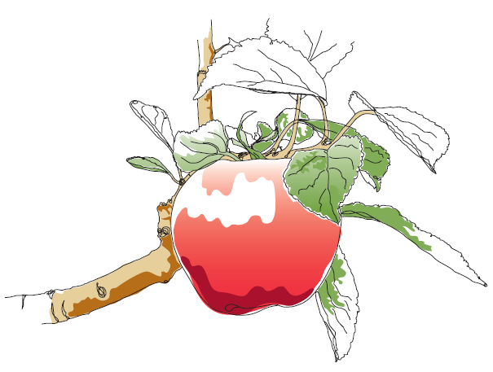
This information and other practical guides are available on the orchard pages of our website at www.ptes.org/orchards

