Orchard pests and control
Natural predators as pest control
The species that act as pests in our orchards have natural predators and parasites. These ‘natural enemies’ of pests can play an important role in regulating pest populations. One way of reducing pest damage therefore is to create an orchard habitat that encourages biodiversity and these natural enemies.
Natural predators and pesticides. Many pesticides will kill these beneficial species as well as the pests you are trying to control, which means your first line of defence is removed or weakened the next time the pest species attacks your fruit trees or crop. For example, evidence shows that use of pesticides kills off the natural predator of red spider mite which is slow to recover, resulting in outbreaks of these as a result.
“…although the application of a winter wash may reduce pest numbers immediately, in the long term it could increase them. The effect on natural enemies … would appear to be detrimental. The predator was unable to recover quickly enough to prevent a resurgence in pest numbers.” (Cuthbertson and Murchie, 2006).
Even intensively managed orchards are now moving away from heavy pesticide use in favour of bio-control, mimicking the natural predator-prey relationships found in healthy orchard ecosystems to reduce damage to the fruit crop. This is often referred to as agroecology, the idea that you can reduce pest and disease damage by building in resilience through natural systems. Agriculture is more sustainable and resilient to change when it mimics biological systems.
Predators-pest relationships. We are a long way from understanding all the pest/predator relationships that exist within orchards. In fact there are likely to be worlds of interactions in your orchard that science hasn’t yet mapped or understood. What we do know is that a biodiverse ecosystem is a more robust ecosystem, less at risk of high pest populations.
Many natural predators live in the canopy of your trees such as small soldier beetles, lacewings, earwigs, and hoverfly larvae, or ladybirds that overwinter in loose bark, which naturally help to control pests such as aphids.
Wasps and hornets offer fantastic pest control in spring and early summer, being voracious predators of smaller insects to feed to their larvae. Wasps then have another role in the summer, particularly in cider orchards, whilst on their search for sugar, they inadvertently spread the wild yeasts required for cider to ferment.
Parasitic wasps have the reverse pattern; they act as pollinators in the spring and summer depending on the sugar rich wildflower nectar, then act as pest control in the late summer and Autumn when they parasitise pest species by laying their eggs within them. In this way parasitic wasps help regulate the populations of leaf mining moths and apple leaf midge among others.
Earwigs help prevent outbreaks of woolly aphid and also regulate the populations of other pest species. Both ladybird larvae and lacewing larvae are extremely efficient predators of aphids.
Encouraging beneficial predator species. Apart from not spraying your orchard, there are other ways you can promote beneficial species.
Keep the whole of your orchard botanically diverse. Think holistically. The richer the botanical diversity of your orchard, the greater the array of insects it will sustain that act as pest control agents. This not only includes the plants on the orchard floor and in the hedgerow, but within your trees. Mosses and lichens on trees provide ideal habitat and protection for insects. There are two main reasons for this:
Many natural predators directly rely on nectar or fruit at certain stages of their life cycle. Parasitic wasps and common wasps are good examples of this.
Plant diversity increases the variety and number of insects in general, so you will be increasing the prey available for natural predators. This will help keep predator numbers high enough to tackle pest species and keep predators in your orchard even when pest numbers are temporarily low.
Provide additional nesting sites. This could be nesting boxes for birds if your orchard trees are not mature enough to provide suitable sites. It could also be nesting boxes for lacewings, ladybirds or earwigs. Earwig nesting sites can be made from tightly packed bundles of twigs and straw, protected from the elements however you see fit (we find in a plastic bottle with the bottom chopped off works well) and hung in your trees.
Codling moth
Codling moth is a widespread and common pest of apple fruit. The larvae burrow through the flesh into the core. They feed in the fruit for a number of weeks, excreting a wet dark-brown frass and spoiling the fruit. Eggs laid on leaves or fruit hatch and enter by the calyx (eye), by the stalk or on the side of the fruit. Entry points on the fleshy side are more distinctive and detectable as it forms a prominent red ring around a hole that is often blocked by frass. Entry points at the stalk and calyx ends are more difficult to see, and can sometimes only be confirmed by cutting open the fruit.
Lifecycle After about 4 weeks inside the apple the larvae leave, spin cocoons under loose bark, in cracks in wood and in debris around the base of the tree, where they overwinter and pupate in spring. The adult moth will then emerge from around May, the males fly off to find a mate, but the females, who can’t fly, will crawl up the trunk to wait for a passing male, she will then mate and lay eggs on apple leaves and developing fruit
Control Codling moth is difficult to control once it is already in the fruit, so steps should be taken to reduce the larvae getting to the fruit. A healthy ecosystem acts as a defence against outbreaks of pest species. There are many species that traditionally live in or visit orchards that will eat codling moth at every stage of development. Earwigs are predatory insects and a great ally of orchard owners, predating on codling moth eggs and young larvae. Insect eating birds such as blue tits will also gorge on the larvae where they can, as will various beetles.
Planting trees a good distance away from each other will help reduce the infection of other trees. Pests find it easier to spread in an overcrowded orchard. The flightless female moth will normally climb her tree of origin to mate and lay. If you have a tree that suffers codling moth infestation annually, you can try a number of non-chemical controls.
Banding. Wrapping bands of corrugated cardboard around the trunk from mid-summer offers an alternative place for moths to spin cocoons and overwinter. Remove these every couple of weeks and burn them. Be aware that it will not only be codling moth larvae that use this as a nesting site, so only use this method on trees that suffer infestations. It won’t solve the problem straight away but will gradually reduce the numbers year on year and can be used in conjunction with other forms of control.
Sanitation. For any tree that is regularly infested with codling moth, remove the leaf litter and debris from under the tree. This exposes the cocoons that are overwintering under the tree to predation. Chickens will scratch around under the trees; they will eat a good number of overwintering larvae so reducing infestation the next year.
Removal of infested fruit. Remove any infested fruit whilst thinning. This is only possible for young trees or lower branches of mature trees, but the removal of any larvae will reduce the scale of infection the next season. Clear infested fruit as it drops. Infected fruit should be removed from the orchard, or the larvae killed by immersing the fruit in water for a week.
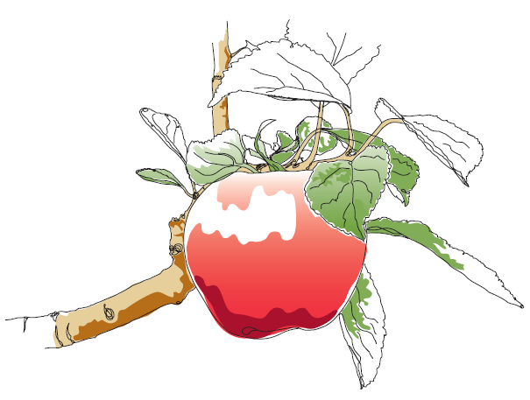
This information and other practical guides are available on the orchard pages of our website at www.ptes.org/orchards

