Framework grafting
Sometimes, for whatever reason, you might want to change the variety of fruit growing on your tree. Maybe you don’t like the apples on it, you would rather have a cooking variety, or you just fancy something different. Instead of grubbing the tree out and starting from scratch which would take many years before you would see any fruit, you can graft your replacement variety directly onto the framework of your existing tree. This allows you to change the variety of fruit growing, whilst keeping the main frame of the tree, meaning you get a crop much much sooner and back to full cropping in 3 years. This process is called framework grafting, or top working.
This method also allows you to create a tree that produces more than one variety of fruit. Care should be taken with this approach to understand the different vigour of your varieties, making sure you place more vigorous lower down and the less vigorous towards the top of your tree. The natural apical dominance of your tree will then give the weaker variety a boost and balance the growth.
Scion wood
As you are grafting onto a whole tree, you will need quite a lot of scion material.
Unlike bench grafting which uses scion wood with only 3-4 buds, you want to be using scion wood with 7-9 buds for framework grafting. You will get very vigorous growth in the subsequent year, and if you have too few buds they will all turn into strong shoots which will eventually turn into branches and crowd your tree. Remember you already have the main framework you want, so too many additional branches are not required. With 7 or more buds, only the upper 2 or 3 will turn into strong shoots the others will produce fruit buds or short fruiting laterals. Unlike with bench grafting, you are grafting onto a well-established rootstock so you can afford the extra water loss from these buds in compromise.
Collecting scion material should be done in the late winter when your source tree is dormant and had experienced some winter chill (plum and cherry varieties have earlier bud movement so this will need collecting slightly earlier in the year than apple and pear material). As a rough rule of thumb, February is about the latest time you should be collecting scion wood. After this the tree is coming out of dormancy, if the buds have come into leaf you are too late. You are looking to collect one year growth, of roughly pencil thickness. [See our guide to scion selection]
Preparing your tree
Before you framework graft your tree, make sure it is the desired shape. Remove any downward growing and crossing branches, and thin out branches from overcrowded areas.
Once you are happy with the general shape of your tree you can begin to take off lateral branches that you don’t want, and reduce the tree to it’s framework. Bear in mind that any lateral branches you wish to stub graft onto should be left, and these are removed at the point of grafting.
Deciding how much of the original tree to remove is a balancing act. The more you remove the longer the time you will have to wait before the tree is back to the same size and cropping levels. However the less you remove, the more chance you will have of missing some fruiting wood and ending up with a mixed crop of your old and new varieties. This, of course, might not be too much of a concern to you if you are not growing commercially.
Clear the tree of lateral growth except for small lateral branches that you plan to stub graft to, and a few extras. It is better to clear less rather than more, sometimes these lateral branches break during stub grafting so having a backup acts as insurance in case this happens. Any extras can always be cut off afterwards.
Grafting
You will need use a number of different types of graft when frame-working a whole tree as you will probably graft to different sized branches.
You can use all manner of grafts when frame-working a tree, but the ones we will discuss here are particularly suitable as together they cover both grafting to large and small branches, and they do not require binding, which would be very time consuming when working on an entire tree.
No matter which grafts you use, there are some general pieces of advice to consider.
- Never graft a new branch directly over an existing one. When your new variety is covered in fruit it will be heavy and droop. You don’t want it coming down onto another branch. Instead aim to have your new branch heading in another direction. If you are grafting many on a branch put them in a herringbone arrangement.
- Think about the placement of every graft. Imagine what it will do to the shape of the tree when it has grown into a branch. It is worth putting the time in to this now so you don’t have to reshape the tree later and waste any growth energy.
- Don’t angle any branches downwards, or towards the centre of the tree. In fact it is best not to graft too close to the centre of the tree at all, this is not where you want your fruit to grow and it is best to keep the centre of your tree clearer to allow for air to circulate and light get in.
- Start grafting at the more inaccessible locations of your tree and work outwards. This way you reduce the risk of knocking out your grafts whilst reaching to graft at another point.
- Remember that the cambium layer (the layer of tissue between the bark and the wood where growth occurs) will be at different depths under the bark with different ages of wood. It is always worth checking you have found the cambium layer before inserting the scion as without cambial connection your graft won’t take.
- When cutting your scion wood into wedge points for any graft be sure not to touch the cut surface as oils from you skin can interfere with the graft and can result in weak or unsuccessful unions.
- When cutting your scion material into wedge shapes for insertion always make sure you have exposed the living cambium layer as without cambium to cambium contact the graft won’t take.
- When preparing the scion for grafting, make sure you cut the base into a wedge rather than the tip, it is easy get wrong.
Stub grafting
Stub grafting is best used where you want to graft scion material directly to small lateral branches/shoots. The end result is directly replacing that lateral with your new variety.
- Prepare the base of your scion material into a wedge, with one cut face being slightly longer than the other.
- Make a cut in the lateral branch that you are grafting on to, on the upper side, and almost to the centre. Take care not to cut further than the centre or you will not have the same ‘spring’ pressure in the cleft to hold the scion material firmly.
- Open the cut by holding down the lateral and insert the prepared scion with the longer cut side downwards. Make sure that cambial tissue from the lateral branch is in contact with cambial tissue on the scion. If the lateral is larger than the scion material this will mean placing the scion to the side of the cleft to match them up.
- Release the lateral and cut it off immediately to the side of your graft. This adds more ‘spring’ pressure and should result in your graft wood being firmly wedged in place.
- Seal all cut surfaces with grafting wax.
Side grafting
Side grafting inserts scions directly into limbs of the tree without then cutting after the graft. It is a good graft to use on comparatively small branches, where your scion material becomes the laterals from this limb.
- Clear any lateral shoots from the limb, and the whole limb will be worked with side grafts. Any particularly well placed laterals can be kept and stub grafted to.
- Cut the base of your scion wood into a wedge with one cut face slightly longer than the other.
- Cut into the side branch at a shallow angle of about 20 degrees, going no further than ¼ of the way in.
- Open the cut slightly by bending the branch, and insert the prepared scion making sure the cambial layer is in contact with that of the branch layer.
- Seal any exposed cut surfaces with grafting wax.
‘Inverted L’ rind grafting
This type of graft is suitable for grafting scion material to larger branches. It can only be done when the rind is easily lifted.
- Prepare your scion base by making a wedge shape that is significantly longer on one side than the other. The long cut should be made at a bud, as when placing this on the branch it will act as a cushion, directing the scion so that it grows slightly out and away from the main branch. The shorter cut is really just to make sure you have the cambial layer exposed.
- Make a smaller cut to the side of the long sloping cut, just a nick enough to expose the cambium.
- Make a cut in the limb, just through to the cambial layer, along the line that you want your grafted branch to lie. Make another cut, connecting to this, at an angle of about 150 degrees to create a flap of rind that can be lifted up.
- Insert your prepared scion under this flap, with the nicked side of the long cut edge under the rind, and the other side on the exposed side of the rind cut.
- Secure the scion in place with a gimp pin, nailed in through the rind, the scion and into the branch.

Wax sealing
Sealing any cut surface serves two main purposes. It reduces the chance of infection entering the tree through these surfaces and reduces the water loss before the wound has had a chance to heal.
I would suggest using a coloured wax that is persistent so that you have a lasting marker of which shoots are grafted on. This prevents you pruning them back out by accident in the winter.
Aftercare
You should get vigorous growth in the year after framework grafting a tree. It might be necessary to shape some of your new branches or prune them. This is best done in the winter with normal winter pruning.
Any sucker shoots from the old variety should be removed. With a persistent colourful wax it is easier to tell these from scions you have grafted on, but still take care. Any scions that you grafted on that are badly placed or are causing crowding should also be removed.

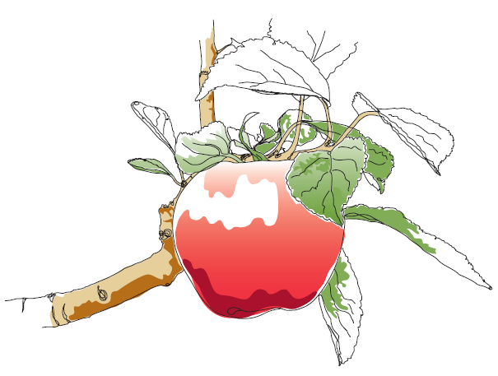
This information and other practical guides are available on the orchard pages of our website at www.ptes.org/orchards

