Formative pruning trees
Formative pruning is the process of shaping a tree when it is young. Every variety has a different natural growth habit, but unpruned fruit trees will for the most part produce a crown cluttered with branches so yielding smaller, lower quality fruit. The aim is to develop an open, balanced network of strong, unshaded branches that will support heavy fruit crops, and at a height that allows for good orchard management such as grazing livestock and machinery. This is achieved by creating a good height trunk and pruning young growth back to encourage the tree to grow in the right direction and develop thick branches.
The desired shape, methods and amount of shaping depend on the type of fruit tree and the vigour of the rootstock. Stone fruit (cherry, plum etc.) does not respond as well as apples and pears to pruning so need less work.
Creating the tree shape
By selection and removal of material, a permanent framework can be established that will determine the final shape and height of the tree. When deciding what growth to keep or remove, consider the tree in three sections. 1) The main stem, or trunk, connects to 2) the framework branches which in turn hold 3) the lateral branches. The framework branches are the major limbs which are usually retained for long periods, if not the entire lifetime of the tree. The smaller laterals, or side branches, will bear leaves and fruit and are pruned and renewed on a more regular basis, mostly through summer pruning.
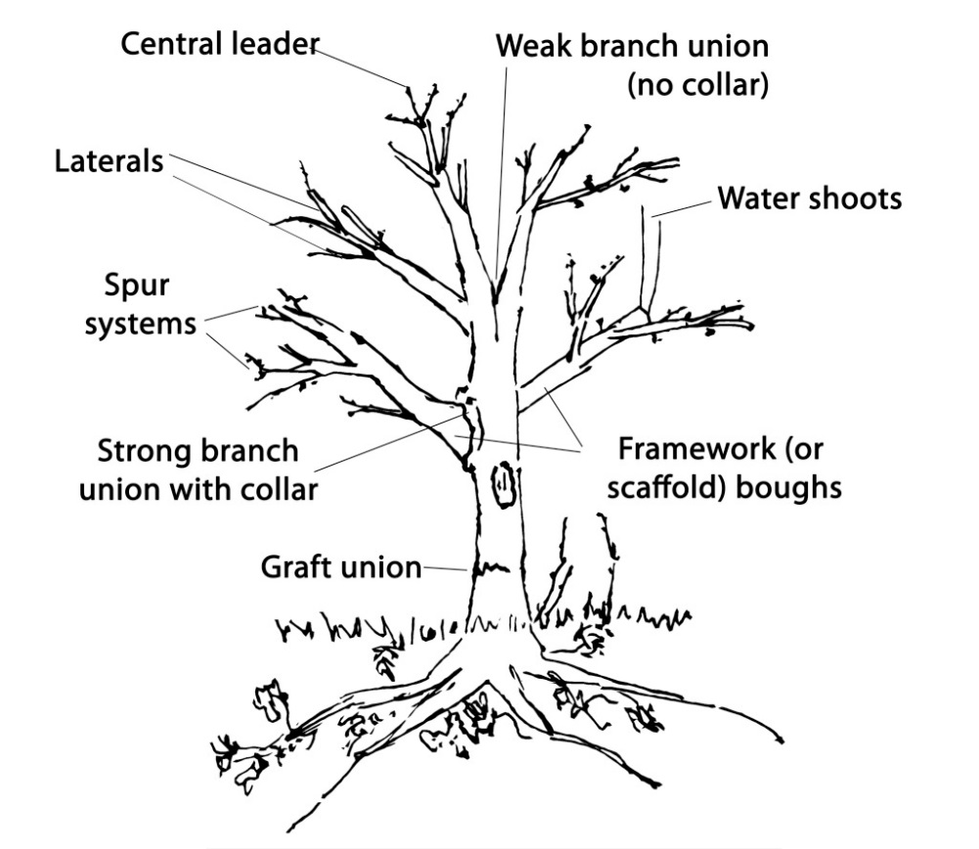
This is the most important period of pruning during the tree’s life. If neglected the tree will produce a smaller crop and require later corrective work. Young trees that are not pruned may develop thin, vertical, overcrowded, crossing and badly placed branches affecting yield and mechanical strength. The ideal is to create strong, well-spaced laterals (horizontal branches which will bear the leaves and fruit) to support the weight of the fruit and ensure it gets as much sun as possible to help the fruit ripen.
Before you start
It is important to know what form tree you are aiming to create. The style of tree shape traditionally varies across the country and between types of fruit. For example cider apples varieties are more traditionally grown with central leaders, but dessert varieties are often formatively pruned into more of a goblet shape, with open centers. The final desired outcome will dictate how to prune from the outset.
Creating the framework
Formative pruning concerns only the main stem and framework. Depending on how large you would like the resulting tree to be, select between 3 and 7 or 8 branches to form a permanent framework. Remove the rest. The lowest framework branch should start a little below the lowest picking height required. When selecting, consider that branches laden with fruit will sag and as the wood hardens it will remain permanently so. Every situation is different. A small garden tree will have low branches with fruit hanging barely off the ground, whereas an orchard managed with livestock or machinery will need sufficient clearance beneath the canopy. Make sure to remove any branches that are growing out of the rootstock below the grafting point and remove any fruit as it starts to develop until the framework is formed, or at least for the first couple of years.
The main aim of formative pruning is to develop well-spaced branches that will allow good air circulation and light penetration. It’s also important to select branches that join at a wide angle. These will form a stronger union with the parent branch which are less liable to split away under heavy fruit crops than narrowly angled branches.
During the formative stages thought should be given to the tree’s natural growth habit. Some varieties produce excessively upright growth. These benefit from tying down with string and pegs, tying weights to the branch, or wedging branches between the forks to force them into a more horizontal plane. A horizontal branch fruits more readily than one growing upright.
- Formative pruning for central leader trees

Cider trees are traditionally grown with a central leader as the apples are shaken off rather than hand-picked.
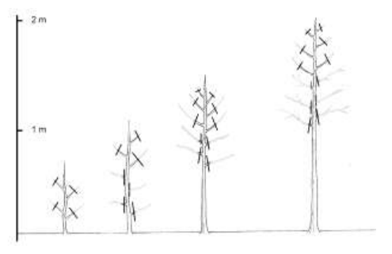
Forming the trunk
- Winter 1. Cut back the side shoots to two or three buds, then remove completely the following year.
- Subsequent winters. Repeat this process on any side shoots coming from the central stem until your tree is large enough to produce side shoots at a height you would like your first framework branches.

Formative pruning standard tree. First 4 winters. Image Paul Lacey Natural England

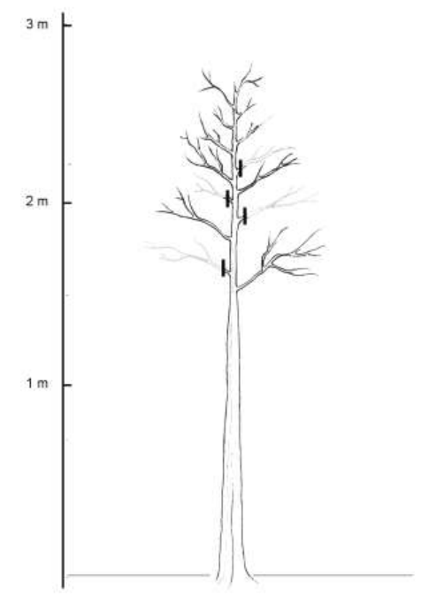
Forming the framework branches

Do not take out your central leader but allow it to keep growing up.

Prune unwanted side shoots (in stages as before) except for side shoots that are at the right height and position to form further framework branches.

Leave 20cm of trunk between each branch to spread out the strain that each puts on the trunk.

Again, you are looking to end up with a tree that has a strong central stem with six to eight framework branches coming off it, evenly spaced around the central trunk.

Formative pruning standard tree. Winter 5 onwards.

Image Paul Lacey Natural England
Pruning framework branches
- While you are establishing your framework branches, prune them by one third of that years growth to encourage the formation of strong branches and well-spaced laterals.

- Formative pruning for open centred fruit trees
Forming the trunk
Formative pruning standard tree. First 4 winters. Image Paul Lacey Natural England
- Winter 1. Prune back any side shoots (sometimes referred to as ‘feathers’) to two or three buds. These will be cut back to the main stem in the following winter prune. This encourages the stem to thicken and builds a strong upright trunk to support the head of the tree.

- Do not prune the leader.

Subsequent winters. Continue to prune back new side shoots to two or three buds (then remove at base the following year) until the central stem has reached the height you want it. The height at which you first develop framework branches will be the height at which they remain throughout the life of the tree. Do not prune the leader until you have reached the height you want your framework branches.

Standards. If you are forming a standard, you want to let the central leader grow to about 2m (6 ft) before allowing side-shoots to develop. This will be where the framework branches will grow, out of the way of grazing livestock.

Half standards. Let the leader grow to about 1 or 1 ½m (3-5 ft) before allowing side-shoots to develop. This will be where the framework branches grow from, and so will be the final height of the central trunk. With half-standard trees, the framework branches should be formed upwards in place of the trunk to create a multi-stemmed tree.

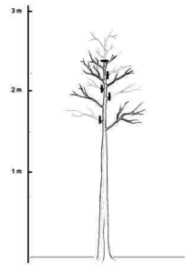
Forming the framework branches

When the trunk is the height you would like your first framework branches to grow from, leave the side shoots at this height un-pruned. Select three or four of these that are evenly spaced and that form wide angles with the trunk, prune them by half to an outward facing bud. These will become your first framework branches.

You might or might not want to produce further tiers of framework branches. If so, keep the central leader un-pruned and repeat this process. This is known as delayed open centered tree form.

Leave 20cm (8 inches) of trunk between each branch to spread out the strain that each puts on the trunk. Ideally you are looking to end up with a tree that has a strong central stem with six to eight framework branches coming off it, evenly spaced around the central trunk.

When your tree has reached the height you want your trunk to reach, prune the central leader to this point. From this time on, the growth of the trees will be directed through the framework branches

Pruning framework branches
While you are establishing your framework branches, prune them by one third of that years’ growth to encourage the formation of strong branches and well-spaced laterals.

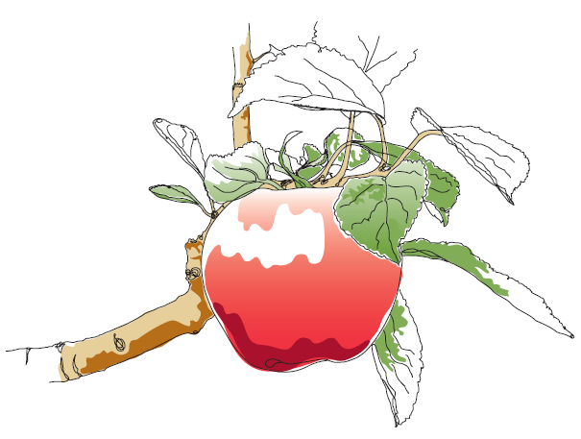
This information and other practical guides are available on the orchard pages of our website at www.ptes.org/orchards

