

# **Bud grafting fruit trees**

Bud grafting involves grafting the vegetative bud from your chosen tree variety to a rootstock. This method is good in situations where there isn’t much young growth available, such as might be the case for old trees. There are many methods of bud grafting but below will show you chip budding.

**Timing**

This process is done in the summer, between July and September so that the bud has enough of the growing season to heal into the rootstock, but reaches winter dormancy before it can grow. This means that you can chip bud any rootstocks where spring bench grafts have failed, giving you another chance at propagation success in the same year.

**Selecting suitable buds for grafting**

As with bench grafting, you want to select your bud material from twigs grown in that year. Find this year’s growth by following down a newly grown twig from the tip, the point at which the bark changes and there is a ridged banding in the bark is the point at which it started growing after the winter dormancy. From this point to the tip is this year’s growth, and so that material you are after.

**Bud grafting and binding**

1. Cut off a scion of this year’s growth, and cut off the leaves (leaving the leaf stalks), this stops the scion drying out by losing too much water through leaf transpiration. You will find the buds that you are going to graft to your rootstock between the leaf stalk and the stem. It is best to choose a bud from the central section of this year growth. Buds close to the base are woodier and more difficult to cut off, buds near the tip are a little too immature to take

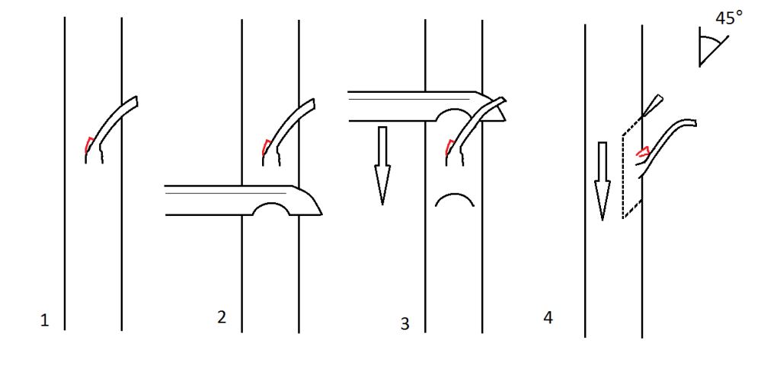

1. Make a cut at about 45° down into the scion wood, about an inch below the bud. The cut should be deep enough to go through the rind and slightly into the heartwood, but not deeper.
2. Remove the knife and do exactly the same about one inch above the same bud.
3. From here, carefully draw the knife down behind the bud, in a slicing motion making use of the whole length of the knife, until you reach the first cut.

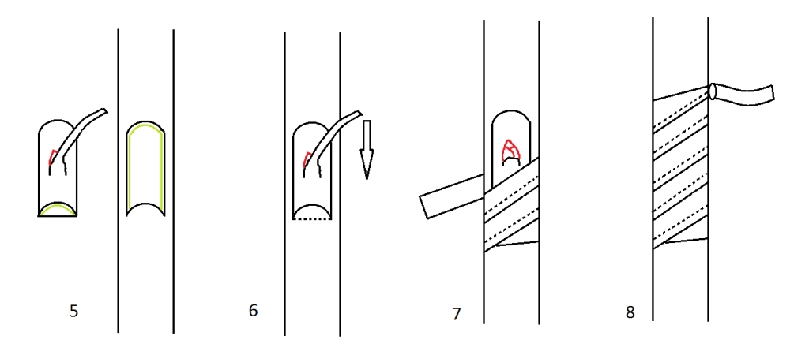

1. Using the leaf stalk as a handle, remove the bud. Be careful not to touch the cut surface as the natural oils and dirt from your skin can interfere with the grafting process of ‘healing’. Carefully, and using the cut out bud as a size guide, take a corresponding slice out of a bare patch of your rootstock.
2. Insert the bud slice into the rind gap you have just created in the rootstock. It should be partially held in place by the flap at the bottom that you created with your first 45° slice. Take care to ensure that the bright green cambium layers of the bud and rootstock sections meet, as it is these growing regions that will heal together. Holding the bud carefully in place, press down on the leaf stalk until it breaks off. Its job as a handle is over.
3. Starting from the bottom, firmly wrap the bud in place with grafting tape (although if you are caught short, strips of freezer bag or cling film can work). Make sure you overlap the tape as you wrap it up, over the bud itself, and right up over the top cut.
4. Unless you have self-adhesive grafting tape, tie it off with two half hitch knots. The purpose of binding the graft is twofold; firstly it holds tightly the cambium layers together to ensure good enough contact for healing, and secondly it stops the graft from drying out.
5. Label your tree with the variety name, rootstock type, date grafted and how many grafts.

**Aftercare**

The graft should heal in the following four weeks, but it is best to keep it wrapped up until the following spring. Before bud burst in spring, carefully remove the binding to see whether it has taken.If it hasn’t, don’t worry, you still have a viable rootstock that you can bench graft with and have another go.

If it has taken, then cut the top off the rootstock down to just above the bud you have grafted, sloping your cut away from the bud to direct away rain water.

If both your grafts have taken, decide which one looks stronger and cut off the other.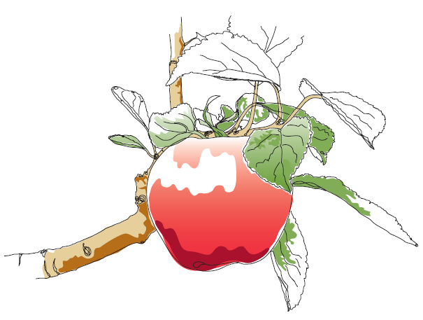

This information and other practical guides are available on the orchard pages of our website at [www.ptes.org/orchards](http://www.ptes.org/orchards)