Bench grafting fruit trees
Bench grafting describes the joining a piece of scion wood onto a new rootstock to create a tree. It is carried out in late winter or early spring using dormant scion wood from a tree of the variety you want to propagate. There are many different methods of bench grafting but the ‘whip and tongue’ is a popular one with high success rates, so that’s what we describe here.
Whip and tongue graft
The whip and tongue graft is probably the most widely adopted method of bench grafting. Ideally choose root and scion material of the same thickness as this maximises the chance of cambial contact all the way around. However if your scion wood is thinner than your rootstock you can adjust the graft slightly to accommodate this.
The cambium layer between the wood and bark is where active growth occurs. Joining the cambium layers of the root and scion is crucial to the success of the graft. In whip and tongue grafting this is done when corresponding cuts through rootstock and scion material are joined end-to-end and then bound. The interlocking ‘tongues’ add structural support to the join as the cambium layers heal and fuse together, as well giving a larger surface area of cambial contact.
This graft is best done in late winter or early spring and it is extremely important that the scion wood is dormant, with no signs of growth.
It is worth practicing this on some spare pieces of fruit scion beforehand so that you are confident with the cuts you are making. Hawthorn makes good practice wood if you are short of scion material.
Be careful not to touch the cut surface of either your scion or rootstock, as oils from your skin can interfere with the healing of the graft.
You will need:
- Rootstock
- Scion wood of your chosen variety – see scion selection guide
- Grafting knife or similar sharp knife
- Grafting tape – florist tape or strips of freezer bag will do if you can’t get hold of grafting tape
- Grafting wax – candle wax mixed with a little petroleum jelly to reduce melting point works
- Tree label
- Waterproof marker pen

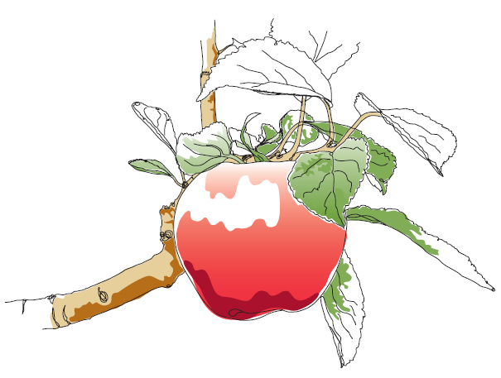
Whip and tongue instructions
- Make a slanting cut through the scion wood with a sharp grafting knife. Aim to create a flat oval cut face between about one and two inches long. This cut should ideally be done in one go, as this slice needs to be smooth and flat. Longer cuts will give better support, but are more difficult to get completely flat, as well as to bind tight along the length of it.
The best way to make this cut is by holding the knife in your dominant hand, the wood in the other, and cut with a pulling motion parallel across your chest and away from the hand holding the wood. Try to make this cut with a single slicing motion using the length of your blade. Using a straight edge, like the back of your grafting knife, you can assess whether your cut is roughly straight, if not then try doing again. It is worth getting this bit right.
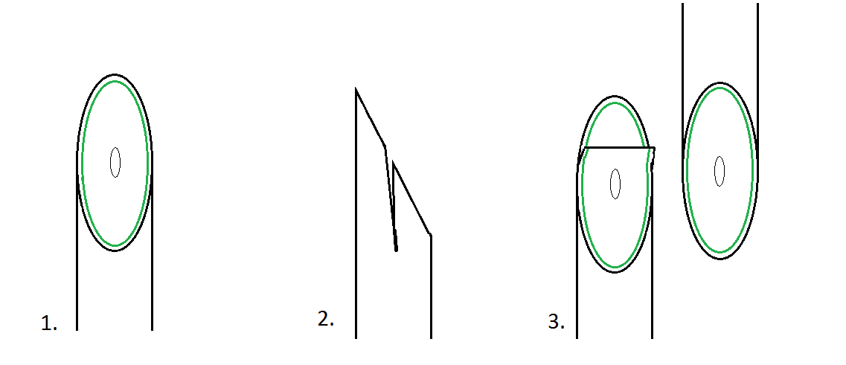
- Make another cut downwards into the scion wood, about one third of the way from the top of the cut face, about half an inch deep. This is a dangerous and difficult cut, as you are often cutting towards your hand that is holding the work. To minimise the risk of damage, place the outside edge your cutting-hand thumb over the end of the thumb of the hand holding the material to ‘lock’ them in a figure ‘T’. This will give you more control and reduce the chance of the knife slipping. This creates one of the ‘tongues’ that will interlock and hold the join fast.
- Make a corresponding slanting cut in your rootstock. Match up these cut surfaces, to check that they are the right length, and that if held together the cambium layers meet. Make any adjustments to your cuts if necessary. A small gap is ok as the binding will pull the pieces together.
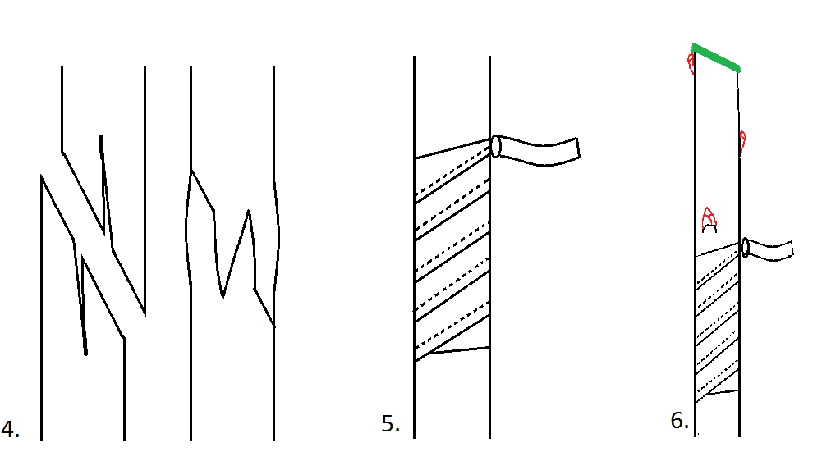
- Make a matching tongue cut of equal depth in the scion wood. Line the cuts up, and slide them together, making sure to interlock the tongues. Check again that the cambium layer of each is in contact with the other. This is crucial to the success of the graft.
- Wrap the graft tightly with grafting tape or something similar. This helps keep the cut sides pressed firmly together, and also reduces the loss of moisture from the cuts. Tie off with a half hitch knot unless you are using self-adhesive grafting tape. Alternatively you can tie your graft together with strips of freezer bag, florist tape, string or even elastic bands, but for the latter two make sure to cover the grafted area with grafting wax afterwards to make it watertight.
- Cut the scion wood at a slanting angle away from the third good bud above the graft. Cover this cut surface with grafting wax to seal it. Make sure the wax isn’t too hot otherwise you can damage the top bud, just melted will do.
- Label immediately with the variety, the rootstock, and the date of grafting. It is all too easy to forget what you have by the summer.
- Dig your tree in to a pot of soil or a bed in a sheltered position out of the sun while the graft heals.

Aftercare
- The graft needs to heal before your new tree will start to grow. This can take anywhere from a couple of weeks to a couple of months, depending on the conditions. Once the top bud has grown an inch or so you can be happy your graft has taken, and the plant can be moved into a sunnier position.
- Once it is clear that the graft has successfully taken cut off all but the strongest shoot, usually the top one, as well as any growth below the graft. Remove any other shoots for the first few years of growth.
- Carefully remove the tape around mid-summer. If it has taken the graft should be healed and the young tree growing. If you wait too long to remove the tape, you can strangle and kill the graft.
- Grafts that have taken and grown over the summer can be planted over the winter, or grown on for another year first. If you plant them out the winter after grafting, make sure to clear the area of plants as these will compete for water and may grow to out-shade your young tree or create a microhabitat that is too humid. If you grow them on for another year before planting out, pot up after the first year to refresh the soil and give the roots space to develop outward rather than forming a tight ball or winding around the container base.
This information and other practical guides are available on the orchard pages of our website at www.ptes.org/orchards

