Grafting
To produce a tree of a known variety, you need to graft from material of that variety. To do this with fruit trees you take scions (essentially new twigs) or buds, and graft them on to a rootstock. You then have the roots of one tree, and the branches, leaves and fruits of another; your chosen fruit variety. In fact most fruit trees are cultivated like this as fruit tree varieties don't grow true from pips. If you plant the pip of a Bramley’s seedling apple, the resultant tree will be an apple, but not a Bramley. To get a Bramley, you need to cut off a scion or a vegetative bud, and graft it on to a rootstock. This essentially clones the tree, growing one with the exact genetic makeup so preserving the variety true to form. If you think about it, this means all Bramley trees have exactly the same genetic makeup as that first original tree.
It might sound like a daunting process but grafting can actually be quite straight forward. As long as you follow a few simple rules, you should find that you make successful grafts from the start. The two most crucial considerations for successful grafting are timing, and cambium contact. These will vary depending on the types of graft you are attempting.

Cambium layer
Understanding the cambium layer is crucial to grafting success. The cambium is a layer of tissue just under the tree rind. In the growing season this will look slightly translucent compared to the tissue either side. This is the layer of active growth in fruit trees, growing to produce the tubes that carry water and sugars around the tree. For a graft to be successful, the cambium layer of the rootstock and the cambium layer of the scion or bud need to be held in contact. These layers then grow together forming a healthy graft union.
Any method that joins the cambium layer of compatible components together, with sufficiently favourable growth conditions has the potential to achieve a graft union. Although it is only necessary to have a small area of cambial contact, larger and firm contact is more likely to give you swift establishment and an effective union.

Scion wood
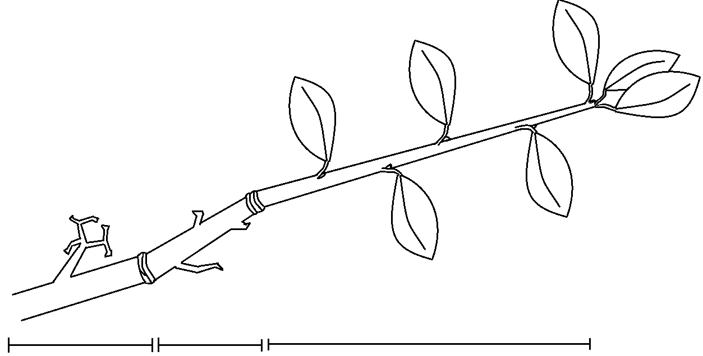
- Three year wood with spurs and fruiting buds.
- Two year wood with fruit buds.
- Year wood, cut for scion material.
c.
b.
a.

Scion selection
A scion is a piece of vegetative material that you will graft with, from a tree that produces the fruit variety you want. For grafts like whip and tongue, graft material is collected in the winter when the trees are dormant.

One year wood
When selecting scion wood you want to find last year’s growth, ideally shoots that are about pencil thick. Find one year wood by following a new growth branch tip down towards the older wood until you find a growth scar. Growth scars often appear as a cluster of little ridges, wrinkles or rings on the wood. Anything that has spurs coming out of it is older than one year old.
If you want to graft using material from an old tree, you might find that it doesn't have a huge amount of new growth from which to cut your scion material. If so, your tree can be stimulated into producing vigorous new growth through winter pruning. Winter prune harder than you ordinarily would perhaps removing a whole branch if you think your tree can take it. This should trigger new growth by spring that can be cut for scion wood the following winter.

Size and shape
Aim to collect straight growth of roughly pencil thickness, which is the rough thickness of the rootstock you will be grafting to. Having the rootstock and scion material the same thickness enables more cambial contact so increases the likelihood of success and strength of your graft join. Cut these from your tree just before the growth scar. The end will dry out and be cut off before grafting, so this gives you the most amount of year-wood to work with.
Timing
Scion wood should be cut in late winter or early spring when your tree is dormant, that is, not in active growth and with no leaves. This is absolutely crucial to the success of any grafting you do from these scions. Fruit trees are dormant through the winter months, so material can be collected any time until about February.
The best time to cut your scion is just before you graft with it as scion wood can lose its vitality as it dries out over time. However this is not always possible, and sometimes you will need to store the wood before cutting it. If you cut your scion material early in winter you need to store it longer in cold storage, which increases the chances of your material drying out. For this reason it is generally advised to cut in the late winter rather than early, minimising the time in storage.

Storage
Having cut your scion material whilst dormant, you need to keep it this way until you graft with it. This means putting it in storage, with enough moisture so that it doesn't dry out and die, but not enough to risk rotting. To store your scion wood you have two main options, refrigeration or 'heeling in'.
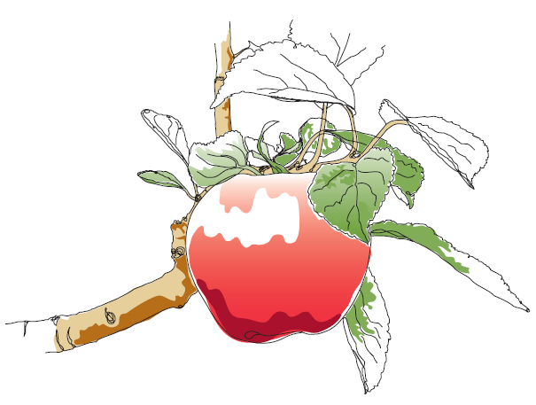
If storing in the fridge, wrap your scions in damp paper towels and seal in a plastic bag to lock the moisture in. Make sure there is no fruit in the fridge as this will reduce the success rates of your stored scions. If you don't have the refrigeration capacity, then you can heel your scions into a ditch filled with damp sand and soil mixture. If you are choosing this method of scion storage you will need to cut your scions longer than usual, as the base will dry out and become useless for grafting.
This information and other practical guides are available on the orchard pages of our website at www.ptes.org/orchards

